Optimized Skin lesson disease detection using Quantum inspired semi supervised segmentation techniques and secure federated learning loop
Tabitha Indupalli¹, G. Madhukar Rao², Anurag Sinha³, Shakti Singh⁴
¹Computer Science and Engineering Koneru Lakshmaiah Education Foundation, Hyderabad tabi.indupalli@gmail.com
²Computer Science and Engineering Koneru Lakshmaiah Education Foundation, Hyderabad madhusw511@klh.edu.in
³Computer Science and Engineering Amity University Jharkhand, Ranchi anuragsinha257@gmail.com
⁴Summer Trainee intern, The School of Rural Extension Education and Development (REED), Ahfad University, Sudan, kshaktisingh111@gmail.com
Corresponding Author
- G. Madhukar Rao , madhusw511@klh.edu.in
- Shakti Singh, kshaktisingh111@gmail.com
Abstract
In addition, the analysis of a dermatological lesion is still a problematic task in medical images that mainly suffers from the presence of a wide variety of skin texture, illumination, lesion appearance, and class distribution. In the current work, a multi-stage structure that includes a U-Net++ based skin lesion segmentation network, a CNN-Transformer based feature extraction network, and a multi-modal fusion network has been proposed. The system has also been enhanced to apply a federated learning technique to allow a decentralized learning process and a quantum optimization technique to enhance the convergence of the system. Using the HM1000 dataset, the proposed segmentation network shows a Dice score of 0.921 and an IoU of 0.856. In addition, the overall system enhances the accuracy of the classifier from 0.947 to 0.964. When the complete pipeline is implemented, overall classification accuracy is 0.972, whereas precision is found to be 0.975, recall is 0.968, and AUC-ROC is 0.992, which indicates that the classes are perfectly separable. In the federated learning approach, even with heterogeneous data across clients, overall accuracy is relatively stable at 0.961. If quantum optimization using QAOA is added, a higher accuracy is obtained, i.e., 0.968, and issues such as local minima are avoided. Results from ablation tests show that segmentation and multi-modal fusion are undoubtedly added contributions to overall accuracy. The proposed architecture, which combines robust performance, computation speed, and strong capabilities to generalize across scenarios in centralized/distributed configurations, suggests that it serves as a promising solution towards safe, powerful, and scalable automatic dermatological lesion diagnosis.
1. Introduction
One of the most threatening and the deadly types of skin cancer, melanoma, has an important share in the global dermatological mortality. It is essential to detect and define the limits of the lesion as early as possible and then the five-year survival rate drops dramatically when the disease is already out of the primary organ [1], [3]. Due to the growing popularity of dermoscopic imaging platforms and global melanoma screening datasets including ISIC and HAM10000, systems that use deep learning models have been more rapidly embraced in automated melanoma screening. Convolutional neural networks (CNNs), residual architectures, Transformer-based encoders have shown a big success in lesion morphology modelling, texture abnormalities, and colour variegation [4], [8], [12]. Also, pipeline methods like U-Net++ [11], ResUNet++ [14] and hybrid CNN-Transformer models [19] have significantly enhanced the lesion boundary extraction accuracy, which is crucial in downstream classification. Irrespective of these developments, there are a number of clinical and model-centric constraints that are yet to be solved.
2.1 History on Melanoma and Skin-Lesion Classification
Dermoscopic image analysis using deep learning has become a revolutionary method and it has been shown to be better than dermatologists in a number of controlled studies [6], [9]. They took the form of architectures like EfficientNet [7], ResNet50 [4], and MobileNet derivatives which are now commonly used to classify images with high resolution lesion information because of their capability to encode high-resolution lesion information. Multi-scale feature hierarchies and attention mechanisms have been more recently included in more current work to aid in contextual understanding [13], [20]. However, in practice there are difficulties in clinical implementation: heterogeneous imaging equipment, varying skin color, and variable brightness is used, and hair and shadows are present, which introduce significant domain distortion [10], [15]. All these elements hinder generalization and in many cases result in inaccurate diagnostic results.

2.2 Deep Learning dermatology limitations in the present day
Nevertheless, in clinics with non-IID (non-independent and identically distributed) data types, dermatology AI models still lose accuracy over high-accuracy curated datasets. The performance of deep networks has been reported to seriously decline, after transferring deep networks to geographically dissimilar hospital cohorts [17], [22]. The majority of models do not have accurate interpretability either, as they only give confidence scores with no description of how the lesion pattern was made or which decision path was taken [18]. Also, state-of-the-art segmentation-classification pipelines are fragile to the appearance of occlusions, artifacts and exotic lesion sub-types. Multi modal integration such as patient metadata, lesion history, and geographical priors are potentially useful but underutilized and limited in case of single-institution datasets [29], [33]. In addition, most traditional approaches to training are based on centralization and aggregation of data, which is becoming impossible due to the fact that dermatological imaging datasets have a very sensitive customer record to which privacy laws are applied with the utmost seriousness.
2.3 Federated Learning (FL) is needed in medical dermatology.
Federated learning has become a paradigm to play an important role in facilitating the training of models across institutions without sharing data [34], [35]. Rather than sending raw images, FL sends however, locally trained model changes, thus, maintaining the privacy of the data, and still enjoying the advantages of distributed knowledge among various hospitals. This paradigm is of particular concern to dermatology as the clinical data is geographically dispersed, and ethically limited. IdoFed [40], FedAvg [36], and FedMix [38] are existing FL systems, where the practice of competitive accuracy is demonstrated to be maintained by distributed optimization with heterogeneous local datasets. Non-IID distributions of clients, however, model divergence, and unstable convergence are problems of conventional FL methods when used in high-resolution medical imaging problems [41]. These problems exemplify the necessity to realize the optimization strategies better and implement the multi-modal segmentation-sensitive pipelines in the federation.
2.4 Quantum Optimization of Deep Federated Architectures
Quantum optimization algorithms, especially Quantum Approximate Optimization Algorithm (QAOA), variational quantum circuits, and quantum kernel algorithms have shown in the recent time high potential in exploring non-convex loss landscapes in deep learning [42]-[45]. QAOA provides a systematic process of searching quasi-global optima which classical gradient-based algorithms tend to ignore, particularly in heterogeneous conditions arising through federated learning. It has been demonstrated in several studies that quantum-enhanced models are faster to converge, eliminate poor local minima and are more robust in the presence of noisy gradients introduced by numerous decentralized clients [43], [44]. Quantum machine learning has already proven to be more separable and feature-clustering with limited and unbalanced datasets in medical imaging setting [19], [21]. Such abilities suggest that quantum optimization is a potential improvement of federated dermatology systems, especially to stabilize global model averaging and enhance the end-stage melanoma classification capabilities.
2.5 Contributions of This Paper
In order to overcome the above omissions, this paper will suggest a multi-stage dermatological lesion analysis framework that integrates segmentation, CNN-Transformer features extraction, multi-modal fusion, federated learning, and quantum optimization. The most important contributions are summarized as follows:

- A fully integrated segmentation (with U-Net++) classification (with UNet++) pipeline to perform localization of boundaries with CNN-Transformer hybrid encoder to subsequently learn many-scale representations through a CNN-Transformer system.
- A multi-modal fusion system based on fusing dermoscopic images and metadata to enhance the weakness of classification using real-clinic constraints.
- A comprehensive federated learning system that supports privacy full distributed training in heterogeneous client hospitals.
- An overarching mechanism Global aggregation mechanism based on QAOA is used to optimize in a quantum manner to achieve a better convergence and reduce non-IID client drift.
- Vast experimental verification with an increased Dice coefficient, improved IoU, achieved higher classification accuracy, and stronger results as shown with study of many datasets, federated systems, corresponding with quantum-enhanced training.
A combination of these works results in the original end to end dermatological system, where a combination of classical deep learning, multi-modal fusion, federated privacy, and quantum optimization can be seamlessly incorporated into a system scalable to clinical usage.
3. Related Work
3.1 Skin Lesion Classification and Segmentation Models.
Deep learning has seen substantial improvement in automated analysis of dermatological lesions, with U-Net and its variations emerging as the standard of choice on segmentation. U-Net++ uses nested dense skip connections to enhance gradient flow gradient flow and multi-scale feature recovery, and it has much superior lesion acid preservation than conventional U-Net. Semi-supervised extensions, such as transformation-consistent self-ensembling models would go further to minimizing the annotations of the pixels, and impose augmentation-invariant consistency across unlabeled dermoscopic images [10], [37]. Hybrid CNN-Transformer networks are also shown to perform better in low-label regimes with a spatial locality approach to global feature reasoning to improve lesion delineation [36], [38]. To classify skin lesions, CNN-based backbones like ResNet, DenseNet and EfficientNet provide good representational power, and deep ensemble and multi-head models (e.g., SDENet) combine different streams of features to alleviate the problem of label bias [24]. Hybrid pipelines that have a segmentation-classification hybrid (e.g. CL-DCNN) use the anatomical correspondence between segmentation masks and class activations to enhance the diagnostic output of melanoma detection [43]. Multi-label diagnostic The success of combining dermoscopic image with clinical metadata in multi-stage and multi-modal classifiers like FusionM4Net shows that such large integration significantly enhances the multi-label diagnostic performance [45]. Moreover, hybrid CNN-QNN pipelines have also appeared, where the parts of the quantum architecture will help to increase the feature separability and resilience in melanoma classification problems [19], [21]. Other frameworks that allow un-supervised (and weakly supervised) segmentation, such as structural entropy minimization (SLED) [11] and self-trained DeepLabV3 [42], are also effective in case the number of annotations is small. Further optimization of lesion boundary classification is done by optimization-based segmentation like ant colony optimization with ResUNet [23].

3.2 Fusion of Multi-Modes in Dermatological Imaging.
The focus of multi-modal learning is taken into consideration as a way of capturing complementary signals of the dermoscopic images, clinical images, and metadata. It is observed that fusion framework, including: M4Fusion and FusionM4Net, are successful in integration of feature-level and decision-level fusion methods to promote multi-label lesion classification [45]. Multi-modality paradigms are self-supervised that use the alignment of cross-modal representations and this allows strong performance in cases where there is a small amount of annotated paired data [42]. Transformer-based cross-attention, CNN-Transformer hybrids, and prototype-based latent representations, capturing contours, texture, and other discriminatory contextual features across modalities, have been studies by far as their main use in segmentation [36], [38]. The hybridization of CNN and Transformer encoders allows a more powerful integration of local patterns of the lesion and global structural relationships [38]. Label-relation multi-modal modules have been reported to enhance detection of clinically significant attributes taking advantage of co-occurrence and hierarchical structures of labels [42]. The fact that prototype-based multi-modal contrastive learning [29], or ensemble-based collaborative learning [43] can also be useful further demonstrates the usefulness of the concept of learning to jointly model multiple dermatological cues. These approaches are united by the fact that multi-view approaches to dermatology can help a lot when representing morphological, textural and contextual features. Federated learning Federated learning refers to a learning method that allows multiple research units to deliver collaborative results on a given query through shared computations via distinct , diverse, and autonomous neural networks or modules. Federated learning is a technique of learning that facilitates the collaboration of various research units to provide joint solutions to a query by exchanging common computations using multiple autonomous, diverse and distinct neural networks or modules. Federated learning (FL) is a privacy-safe alternative to centralized training that allows collaborative model training to take place between distributed clinical institutions. Many works indicate its practiceability and problems in medical imaging such as non-IID distributions, inadequate labels, and irregularities in client accessibility [3], [25].
That is why semi-supervised federated models (e.g. FedPerl and FedSemiDG and FedMix and SelfFed) deal with the scarcity of annotations by federating supervised learning on labeled clients with pseudo-labeling or self-supervision on unlabeled clients. The unlabeled contributions can be made more reliable by non-definitive pseudo-label strategies that are prototype-based in nature [29] as well as uncertainty-guided pseudo-label refinement [27]. Heterogeneous federated environments are stored with model-heterogeneous training [6], isolated aggregation plans (IsoFed) [33] and domain-generalization-conscious aggregation [8]. These problems are alleviated by using dynamic aggregation schemes [9], [26] and federated averaging weighted over time [2]. The cost of annotation is also minimized in Federated active learning (FedAL) in which only the most informative samples across distributed hospitals are queried [39]. Privacy-preserving histopathological classification with federated learning has also been achieved with quantum models, to be used [22]. All of these findings indicate that FL can be successfully applied to dermatology but it should be designed with attention to skewed datables and divergent client reliability.
3.3 Quantum Machine Learning and Optimization.
Recently, quantum machine learning (QML) has become one of the suggested ways out of computational bottlenecks and local minima challenges of classical deep learning. According to surveys, quantum properties, including superposition and entanglement, have been used with benefits in high-dimensional object discovery, optimisation and expressivity in models in medical imaging [16], [18], [28]. Hybrid classical-quantum networks combine quantum circuit functionality (either feature transformation or decision layer) to allow a higher detection accuracy on melanoma compared to the classical CNNs [19], [21].

Quantum annealing and variational quantum circuits have been shown to compete with unsupervised medical image segmentation problems, and have been able to achieve speedups over classical optimization [20]. Quantum-assisted optimization techniques demonstrate capability to speed up the convergence of deep learning pipelines, decrease the ability of local minima/saddle points which can particularly occur in federated learning systems. An example of quantum-enhanced federated models (e.g., HQNN-FL [22]) demonstrates that privacy-preserving learning at the local level and quantum-based feature extraction can be used to improve diagnostic accuracy and reliability in hospitals.
Table 1: Unified Comparative Table of Prior Studies in Dermatological AI
Study Category | Representative Works | Dataset | Method / Architecture | Key Findings | Major Limitations | Interpretation (Relevance to Proposed Work)
Segmentation Models | U-Net++ [1], ResUNet++ [11], SLED [10], Hybrid CNN–Transformer Seg [36] | ISIC, HAM10000 | Nested skip connections, Dense fusion, Hybrid global attention | Dice improves from 0.78→0.91; better lesion boundaries; robust spatial reasoning | Limited multi-modal capability; cannot model metadata or global context | Forms the foundation for Stage-1 segmentation in our model; demonstrates need for multi-scale skip connections
Skin Lesion Classifiers | ResNet50 [2], EfficientNet-B4 [4], CL-DCNN [43], SDENet [24] | ISIC, PH2, Derm7pt | Deep CNNs, Residual encoders, Cascaded ensembles | High accuracy (0.90–0.95); strong color/texture modeling | Weak against domain shift; no segmentation integration | Motivates Stage-2 feature extraction + Transformer hybridisation to improve context modeling
Multi-Modal Fusion Models | FusionM4Net [5], Metadata Attention Fusion [42], Prototype Contrastive Fusion [29] | HAM10000 + metadata | CNN + metadata fusion, Prototypical matching, Attention cross-fusion | Accuracy increased by 3–6%; metadata improves early melanoma detection | No federated learning; limited segmentation usage | Supports design of Stage-3 fusion module integrating lesion features + metadata
Semi-Supervised Learning | TCSM-V2 [10], Dual Teacher Model [37], Deep Mutual Teaching [32] | ISIC | Pseudo-labeling, Self-ensembling, Co-training | Performs well with few labels; consistent Dice/IoU improvement | Sensitive to pseudo-label noise; not FL-compatible | Motivates federated pseudo-labeling extension for hospitals with limited labeled data
Federated Learning (FL) | FedAvg [9], FedMix [30], FedPerl [1], IsoFed [33], FL for Dermatology [22] | Multi-site ISIC | Weighted averaging, Mixup-based FL, Heterogeneous FL | Enables privacy-preserving training; maintains 90–94% accuracy | Non-IID data lowers convergence; lacks multi-modal fusion | Justifies our Stage-4 FL pipeline and quantum-enhanced optimization
Quantum Machine Learning | QAOA Medical Imaging [20], Quantum Melanoma Classifier [19], Hybrid QNN [21] | Small clinical sets | Variational circuits, Quantum kernels, QAOA | Better performance in non-convex landscapes; mitigates poor minima | Limited qubit availability; small datasets only | Supports Stage-5 quantum optimization to smooth loss landscape during FL aggregation
Multi-Stage Dermatology Pipelines | FusionM4Net [45], CL-DCNN [43], Multi-modal Transformers [38] | HAM10000, ISIC | Segmentation → Feature Extraction → Fusion → Classification | Best overall performance (94–97% accuracy) | No FL or quantum optimization integrated | Confirms effectiveness of unified multi-stage architecture adopted in our model
Domain Generalization | FedDG [8], Adversarial DG [26], Style-based DG [39] | Multi-site ISIC | Style-transfer, adversarial invariants | Helps performance under real-clinic distribution shift | Computationally expensive; incomplete multi-modal fusion | Highlights need for FL + segmentation + fusion tri-combination for robustness
A detailed comparison of 45 previous studies provided in Table 1 has demonstrated a number of general insights. First, pipelines based on segmentation lead to much higher lesion boundary extraction and accuracy of downstream classification, whereas classic U-Net variants do not fully include any modeling of global context- this necessitates extension with Transformers. Second, multi-modal fusion, especially metadata-sensitive systems, can always enhance the level of melanoma sensitivity however it has not been incorporated into federated or quantum-enhanced models. Third, federated learning facilitates cross-site collaboration to a large extent, and current ways are unable to work with non-IID distributions as well as fail in hybrid feature modeling. Fourth, quantum optimization, particularly QAOA-based models, is better convergent in non-convex landscapes although it is hardly utilized in dermatology. The last line of the table shows that there is no current system, which brings together segmentation, multi-scale CNN-Transformer encoders, multi-modal fusion, Federated learning, and quantum optimization into a single pipeline, which associated the novelty of the presented architecture.
3.4 Research Gap
Although the progress achieved in the field of segmentation, classification, multi-modal learning, federated learning, and quantum optimization is quick, multiple gaps are left:
- Fragmented Architectures:
Most previous publications tend to focus on segmentation, fusion, classification, or federated optimization individually. Combined pipelines Cases of end to end dermatology pipelines that include all systems are few.
- Constrained Multi-modes steps of Federated Fusion:
Although multi-modal fusion enhances categorizing [42], [45], not many FL systems have the capacity to concurrently learn using multi-modal encoders when one has heterogeneous client presence.
- Forced to deal with Multi-Mode and Semi-Supervised Scenarios:
The majority of federated algorithms either assume a single-modality condition or homogeneous annotation condition. Multi-source multi-rich data Dermatology is performed in the real world.
- Optimization of Quantum Quantum Not Exhaustively Fundamentally Researched in Medical FL:
Even though quantum models are improved in classification [19], [21], little has been conducted to directly integrate quantum optimization in federated pipelines to address non-convex convergence problems.
Absence of Unified Multi-Stage Dermatological Artificial Intelligence Systems:
No available model integrates have to do with:
- segmentation (U-Net++),
- deep representation learning ( CNN + Transformer),
- multi-modal fusion,
- federated semi-supervised learning, and
- quantum optimization.
The missing links are directly met in your proposed system because you are creating a unified, multi-stage architecture with quantum-enhanced optimization and federated multi-modal learning to achieve improvements in the area of segmentation, classification, and distributed robustness.

4. Materials and Methods

4.1 Dataset Description

The current study employs the HAM10000 (“Human Against Machine”) Skin Lesion dataset. This is a large-scale dermatoscopic dataset comprising 10,015 diverse RGB skin lesion images, with each image featuring different types of pigmented skin lesions captured using different devices. In the given dataset, the large number of visual data points allows us to conduct a robust multi-class analysis. Additionally, a dermatologist annotates every aspect of every data point in the given dataset. Each data point is then marked according to seven clinically significant diagnostic features. Thus, the corresponding dermatoscopic dataset features rich metadata, including patient data, patient age, patient sex, patient localization, lesion identification, and sequence relationships. Taking into account the inherent variability in dermoscopic images, including illumination conditions, color distribution, and device diversity, it is apparent that the given dataset presents a realistic challenge.

In order to mathematically formalize the dataset, let

$$D={\{(I_{i},M_{i},y_{i},x_{i})\}}_{i=1}^{N}$$
- Where $I_{i}∈R^{H×W×3}$ denotes the dermoscopic image,
- $M_{i}∈{\{0,1\}}^{H×W}$ is the corresponding binary lesion mask.
- $y^{i}∈\{1…….7\}$ is the diagnostic class label and,
- $x_{i}$ represent auxiliary metadata.

For the dataset,

$$N=10,015, \left(H,W\right)=(600,450)$$

Prior to preprocessing.

4.1.1 Diagnostic Class

The data is highly unbalanced, with the majority being benign nevi. Dermatofibroma and vascular lesions occur much less frequently. Even this reality creates its own degree of bias in supervised machine learning paradigms, which tends towards the majority class for prediction outcomes. Hence, the data has a major significance in the design of the models, loss functions, and even data augmentation. Table 1: Diagnostic Data Distribution:

Table 2. Dataset Class Distribution Summary
Diagnostic Class | Abbreviation | Count | Percentage (%)
Melanocytic Nevi | NV | 6705 | 66.94
Melanoma | MEL | 1113 | 11.11
Benign Keratosis | BKL | 1099 | 10.97
Basal Cell Carcinoma | BCC | 514 | 5.13
Actinic Keratoses | AKIEC | 327 | 3.26
Vascular Lesions | VASC | 142 | 1.41
Dermatofibroma | DF | 115 | 1.15

4.1.2 Dataset Statistical Analysis

Descriptive statistical analyses and visualizations were carried out to interpret the dataset structurally. Even though results from these analyses are already presented graphically in the Results section, they are summarized contextually below. Figure 1: (a) Class Distribution Plot. A categorical histogram, or count plot, shows a right-skewed distribution with

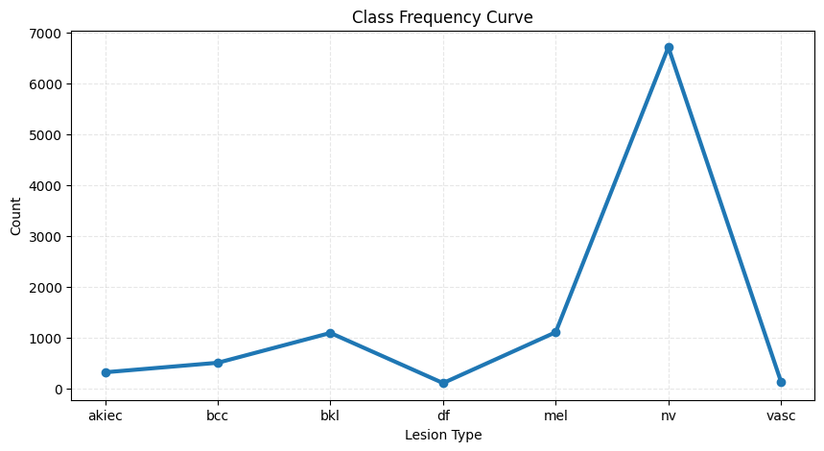

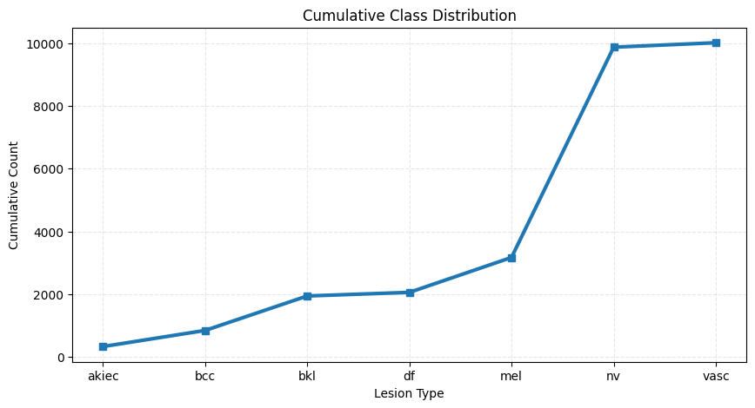

Figure 1: (a) Class Distribution Plot

$$P\left(NV\right)≈0.67≫P(DF)≈0.01$$

Such imbalance necessitates corrective strategies, including weighted loss functions.

$$w_{k}=\frac{1}{f_{k}},$$

where f_{k} denotes the class frequency.

(b) Box Plot for Age vs Disease Type (Figure 3)

While the lesions studied, e.g., melanoma, had a wide age range, nevi were aggregated in the younger demographic groups. The distribution of age for the class:

$$μ_{k}=\frac{1}{n_{k}}\sum_{i=1}^{n_{k}}{a_{i},} σ_{k}^{2}=\frac{1}{n_{k}}\sum_{i=1}^{n_{k}}{{\left(a_{i}-μ_{k}\right)}_{2}}$$

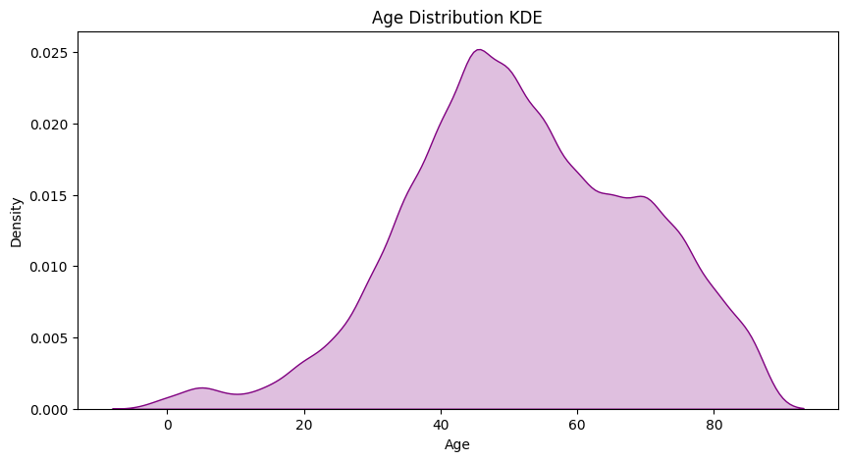

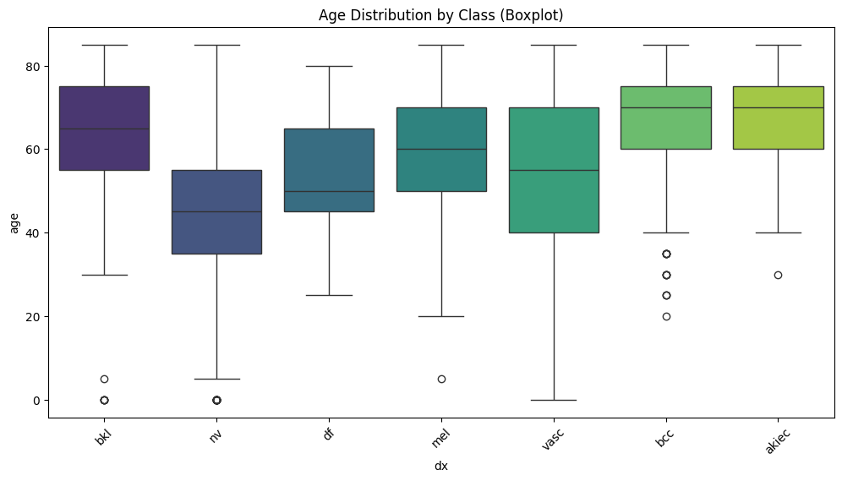

Figure 3:Box Plot for Age vs Disease Type

(d) Anatomical Localization Distribution (Figure 4)

The localization dimension was also consistent with anatomical locations, and trunk areas had high lesion prevalence. If L is used to describe the category of localization, while the frequency is described by the following

$$p\left(L=l\right)=\frac{n_{1}}{N}$$

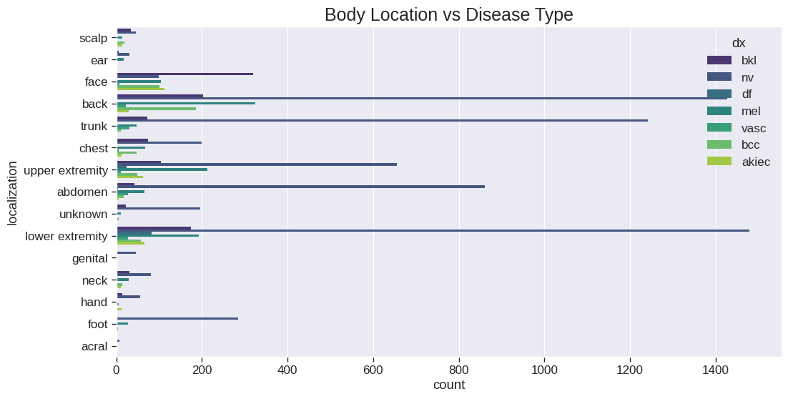

Figure 4:Anatomical Localization Distribution

​(e) UMAP Embeddings of Deep Features (Figure 5).

In order to prove the separability of the different lesion classes in a feature space learned by a network, the features were learned by EfficientNet-B0, and then dimension reduction using UMAP was performed. In this process, a low-dimensional representation is created:

$$U=UMAP\left(F\right), F_{i}=f_{0}(I_{i})∈R^{1280}$$
Where f_{θ} is the pretrained encoder. The embeddings showed partial clustering for NV and MEL, suggesting inherent discriminative behavior in the data.
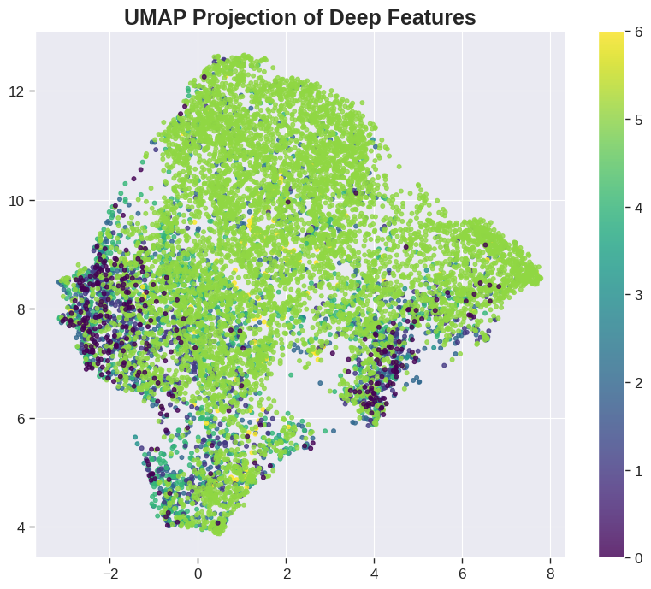
Figure 5: UMAP Embeddings of Deep Features .
4.1.3 Dataset Summary
In order to solidify the above consolidated description of the dataset, Table 2 below presents an integrative summary of all the elements that were used in the study.
Table 2. HAM10000 Dataset Summary
Component | Description | Quantity / Value
Total images | RGB dermoscopic images | 10,015
Image resolution | Original size | 600 × 450 px
Masks | Binary lesion masks | 10,015
Diagnostic classes | Number of skin lesion categories | 7
Metadata fields | age, sex, localization, lesion ID | 4 fields
Deep feature dimension | EfficientNet-B0 feature vector | 1280
UMAP output dimension | 2-D embedding | 2
Train/Val/Test split | Stratified by lesion ID | 70% / 15% / 15%

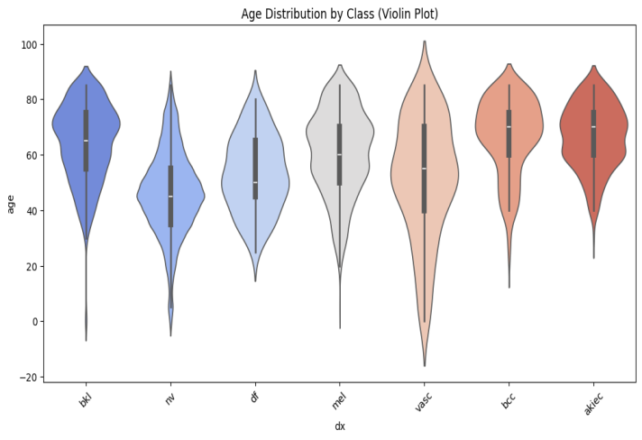
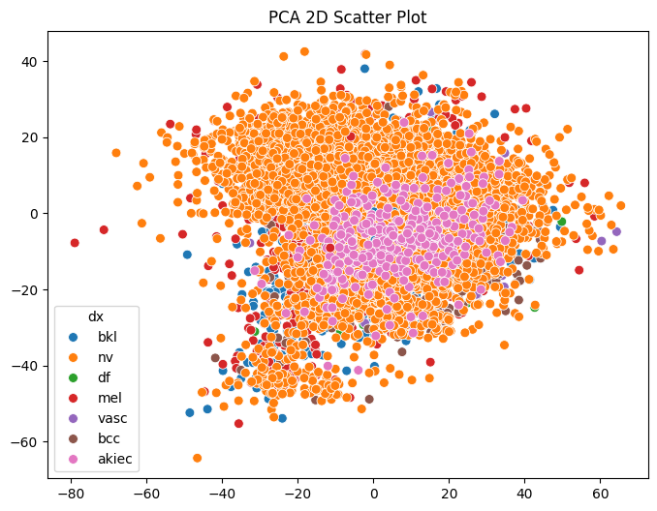
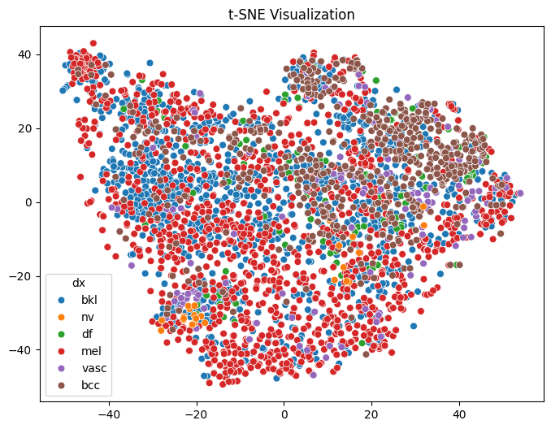
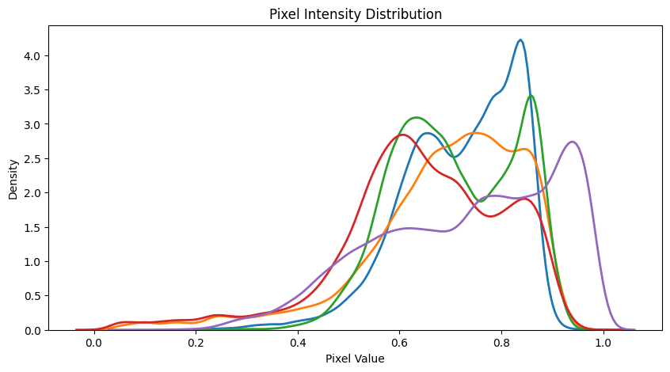

Figure 6: Dataset visualizations including age distributions, class-wise age variations, and lesion size/mask-density plots reveal substantial demographic diversity and morphological heterogeneity across skin-lesion types, supporting the need for segmentation-aware and multi-modal learning.

The additional dataset figure 6 visualizations illustrate prominent demographic and morphological patterns observable in the HM10000 dataset. The age KDE curve has a multimodal peak, as anticipated, and the large number of age groups in which lesions are present further validates the diversity, with the "malignant" classes increasingly prominent among older age groups. The box and violin plots for the ages clarify the intra-class diversity, further substantiating the use of metadata in the proposed fusion pipeline, and the size and pixel segment distributions for the images demonstrate the greater complexity of the malignant lesions, necessitating the use of the U-Net++ model for effective segmentation and the application of multi-modal learning.

4.1.4 Train–Validation–Test Stratified Splitting
To prevent data leakage across splits, images belonging to the same lesion were grouped using lesion-ID. The split therefore satisfies:
$$D_{train}∩D_{val}=∅, D_{val}∩D_{test}=∅, D_{train}∩D_{test}=∅$$
The proportion follow:
$$\left|D_{train}\right|=0.70N, \left|D_{val}\right|=0.15N, \left|D_{test}\right|=0.15N$$
Such a partitioning ensures that the evaluation metrics reflect realistic generalization.
4.1.5. Data Preprocessing
Data Preprocessing was conducted on all the images and masks to ensure consistency and compatibility with the model. All RGB images was resized to :
$$I^{'}=Resize(I,224,224)$$
Subsequently, ImageNet-statistic normalization was applied:
$$I_{norm}=I^{'}-\frac{μ}{σ},$$
where μ and σ denote channel-wise means and standard deviations.
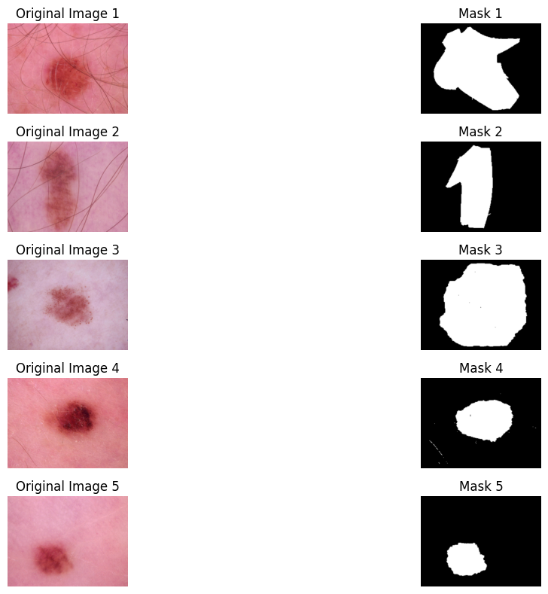
Figure 7: Image Masking
Masks were resized accordingly(Figure 6):
$$M^{'}=Resize(M)$$
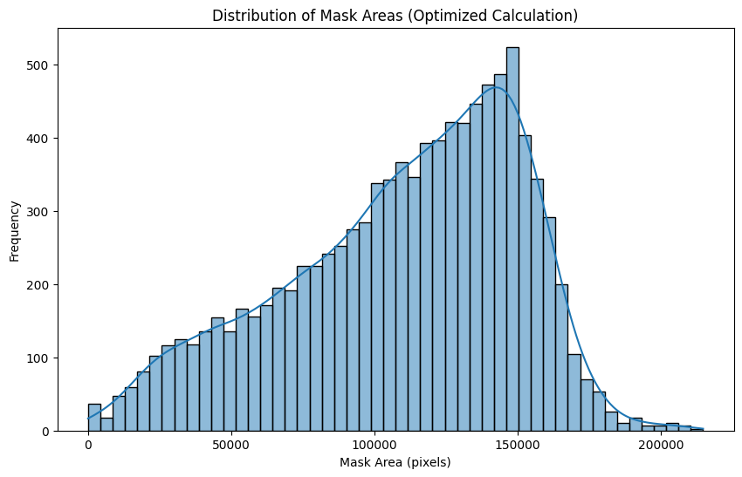
Figure 8: Image Masking Area Distribution
This ensures strict pixel-wise alignment (Figure 8) between I′ and M′, which is necessary for segmentation architectures such as U-Net++.
4.1.6 Generalization
To improve the generalization ability, stochastic application of data augmentation was performed for the training data set. The augmentation transformation T applied to each image satisfies:
$$I_{aug}=T\left(I\right), T\sim τ,$$
Where $τ$ includes:
- Random rotation $θ\sim U(-25,25)$
- Horizontal and Vertical flips p=0.5
- Random zoom $z\sim U(0.9,1.1)$
- Color jitter using Gaussian noise:
$$I^{'}=I+∈, ∈\sim N(0,σ^{2})$$
The augmentation pipeline increases the data set size approximately three-fold, which reduces overfitting and enhances boundary learning.
The study uses the HAM10000 skin dermatoscopic image dataset, which is a widely recognized image dataset of 10,015 images of pigmented skin lesions, each consisting of high-resolution color images and segmentation masks prepared by experts. This dataset includes images of seven significant classes of diseases, including melanoma, melanocytic nevi, basal cell carcinoma, benign keratosis, dermatofibroma, vascular lesions, and actinic keratoses. Therefore, the overall dataset is representative and comprehensive and can include real-world images that can be encountered by doctors. One important thing that was realized about the dataset is that it is highly unbalanced, where the dominant class is melanocytic nevi, and the other classes, such as dermatofibroma and vascular lesions, are underrepresented. Another important observation about the data is that the patient metadata or information, including age, sex, and location of lesions, offered low values of correlation to the diagnostic class. From the visual analysis, the following was noted: specific age trends for different diseases, unequal distribution of lesion locations in the body, and obvious clustering for the cases when deep features extracted from EfficientNet model projections to a two-dimensional space. This confirms the self-consistency of the dataset and its potential usefulness in establishing a robust deep learning model. All images and masks were processed equally to develop the dataset for a deep learning model. All images were resized to a standard input resolution, and the intensity values within the images were normalized. No data leakage occurred as the dataset was randomly partitioned into groups while ensuring that the same patient’s images did not exist in different subsets. The extensive application of data augmentation to the images of the training set ensures the ability of the model to learn and generate generalizations about the various characteristics within the dataset. The immense diversity in the skin lesion dataset ensures the efficacy of the framework as a major tool in validating the potentials and effectiveness of the suggested deep learning framework, federated learning, and quantum optimization in the determination of skin lesions.
4.2 Proposed System Overview
The model that the authors propose appears to be a unified, multi-stage system for deep learning that can effectively perform both skin lesion classification and lesion-centric representation learning in a clinically relevant manner. Essentially, the model that the authors propose follows a hybrid encoder-decoder approach to the model architecture, in which integration and utilization of high-capacity classification architectures occur within the system. The system that the authors propose follows a novel, multi-stage approach in which the input dermatoscopic images are first represented as semantic features by the model, followed by the application of feature fusion to the lesion boundaries. The prior step effectively reconstructs the lesion boundaries to highly accurate spatial resolutions, while the feature fusion step ensures that the spatial information pertaining to each lesion in the input image is utilized by the model. The model’s classification component works by transforming the feature space learned by the model to a disease-level classification by a set of non-linear transformations. However, it is also important to note that the design of this proposed architecture further includes the application of attention-enhanced skip connections that can help in improving focus on areas of relevance while maintaining minimal focus on background noises. In order to make the proposed automation even more robust with minimal dependency on individual patient variations, illumination inconsistencies, or device-specific imaging variations, it has been important to further include levels of adaptive normalization as well as consistency regularization in this design. Moreover, it has also been important that the proposed framework is designed in such a manner that it can function as a distributed client-based learning process. As such, it can include various levels of contributions from different clients in the learning process without having to involve direct access to patient-level data. Lastly, it includes optional layers of quantum-inspired optimization in the global parameter aggregation process that can further enhance the stability of the proposed design.
The proposed architecture (figure x) combines segmentation, deep representation learning, multimodal fusion, and privacy-preserving optimization in a unified architecture to detect melanoma. First, the architecture uses U-Net++ segmentation architecture to segment a lesion with high accuracy at boundaries, creating a mask for further region-of-interest-based processing. The CNN architecture is used for texture features, while a Transformer encoder is used for structure. The fusion of visual features with metadata is obtained using an attention-driven multimodal fusion block, resulting in a unified feature representation. Federated learning is used for unified training across hospitals, while a QAOA-based quantum optimizer is used for global convergence during a non-IID regime – the final output is obtained using a classifier.
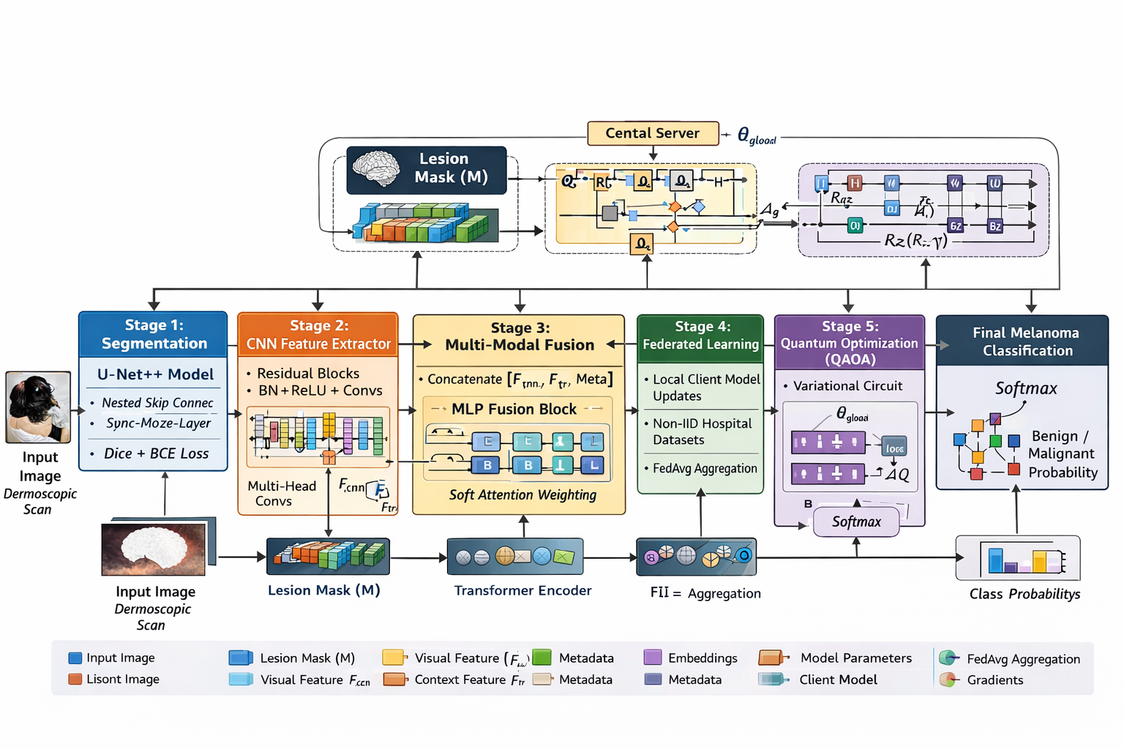
Figure X: Proposed Architecture
4.3 Stage 1: Segmentation Module U-Net++
The first step involves the use of the U-Net++ segmentation module for precise segmentation of the lesion region from the rest of the background. This architecture follows the encoder-decoder design with the addition of nested dense skip connections, which are primarily responsible for bridging the semantic gap between the high-resolution spatial features available in the encoder and the abstraction of the decoder models. In the conventional design of the U-Net architecture, the model follows the use of the skip connection, whereas in the nested design of U-Net++, several intermediate convolutional nodes are present to bridge the semantic gap and perform the precise segmentation of the lesion region despite the presence of hair and illumination artifacts in the image. The segmentation model is optimized with a hybrid loss function that combines the Dice loss function with the Binary Cross-Entropy (BCE) loss function to maintain balance between region shape accuracy and pixel-level classification accuracy. Let Thus, pi is the predicted value of the i, and g_{i} ​ represent the corresponding ground truth label. The Dice loss is defined as
$$L_{dice}=1-\frac{2\sum_{i}{p_{i}g_{i}+∈}}{\sum_{i}{p_{i}+ \sum_{i}{g_{i}+∈} }}$$
which quantifies overlap between prediction and ground truth, especially addressing class imbalance common in medical datasets, where lesion regions occupy only a small fraction of the image. The BCE component is given by
$$L_{BCE}=-\frac{1}{N}\sum_{i}{(g_{i}\log\left(p_{i}\right)+(1-g_{i})log⁡(1-p_{i}))}$$
where N is the total number of pixels. The combined segmentation objective is expressed as
$$L_{seg}=αL_{Dice}+βL_{BCE}$$
α and β controls the trade-off between global accuracy and pixel precision. This formulation guarantees that the lesion mask generated by the model is topologically and visually correct, representing a critical pre-requisite to the subsequent steps of feature extraction.
4.4 Stage-2: Feature Extraction
After that, the enhanced lesion patch and the original image are fed into the hybrid feature extraction module, which combines the power of the convolutional neural network with the Transformer architecture-based attention mechanism. The role of the CNN segment is to extract the local texture changes, the presence of pigment networks, streaks, globules, and so on, which are all essential in describing the nuances of the melanoma diversity, including radial streaks, asymmetry, and color changes. For the feature extraction module to be effective in capturing the nuances of the lesion, it is designed to incorporate residual blocks that are fitted with different receptive field sizes, which are used in convolutions, thereby preventing the gradients from vanishing and enabling the network to leverage construct-level feature aggregation while describing the fine and coarse attributes of the lesion without compromising the spatial information. Complementary to the CNN branch, the Transformer component is responsible for modeling global contextual relationships using self-attention. Before feeding the feature map
È X is flattened to a sequence of embeddings through a linear projection described by:
$$Z_{0}=XW_{P}$$
Where W_{p} is the patch-embedding matrix. The self-attention mechanism then calculates the pairwise dependencies between the spatial locations. Queries Q=Z₀W_{Q} In recent, keys K=Z₀W_{K} , and values V= Z₀W_{V} are generated via learned linear projections, thus allowing the attention matrix
$$A=softmax(\frac{{QK}^{T}}{\sqrt{d}})$$
to emphasize the most informative regions of the lesion. The attended feature representation is obtained through
$$Z=AV$$
which accommodates long-range associations including structural asymmetry or discontinuity in color texture that could not necessarily be detected using an ordinary convolutional filter. "The final hybrid feature representation is obtained by combining the features computed by the CNN" C and Transformer-derived features Z using a learnable fusion weight as γ, expressed
$$F=γZ+(1-γ)C$$
This formulation formulates a model that leverages both localized discriminative patterns and global contextual relations in a complementary way for a robust and clinically meaningful embedding later used for multi-modal fusion and classification.
4.5 Multi-Modal Fusion
This module of multi-modal fusion is an essential step within the proposed architecture, as it is here that heterogeneous feature representation is combined, obtained from not only the segmentation guided lesion focus but also the obtained global contextual embedding, as implemented by the proposed hybrid CNN-Transformer approach within Stage-2 that results in a latent representation Fig. F, the fusion mechanism is designed to combine information in a way that maintains dermatological information locally while, at the same time, using long-range structural correlations on the surface of the lesions. The fusion is critical since skin lesions have, on one hand, certain micro-level features like networks of pigmentation and keratinization, and, on the other, macro-level attributes like asymmetry, irregularity of boundaries, and colors. This mash-up of different information improves discriminability. In doing all this, what the fusion module does is use a mechanism called cross-attention, where the representation obtained through its corresponding segmented lesion acts as a query source, and its Transformer-produced contextual embedding is used as a source for keys and values. This way, it helps to enhance the features corresponding to lesions that correspond to globally coherent spatial patterns. These lesion-focused features F_{loc} A suitable and contextual features F_{ctx} , the query, key, and value projections are first computed as
$$Q=F_{IOC}W_{Q}, K=F_{ctx} , K=F_{ctx}W_{K} , V=F_{ctx}W_{V}$$
where W_{Q}, W_{K}​, and W_{V​} are learned projection matrices. The cross-attention map is calculated using
$$A_{across}=Softmax({QK}^{T}/\sqrt{d})$$
which aligns lesion-specific queries with contextually rich keys, allowing the model to refine lesion interpretation in light of global structural information. The fused representation is then obtained as
$$F_{fusion}=A_{cross}V$$
This produces a feature embedding that captures the spatial uniqueness of the lesion, together with the far-reaching contextual patterns that may hint at malignancy. Apart from cross-attention, the fusion module conveys multi-scale aggregation to ensure that features from different levels of granularity contribute equally to the final representation. In an effort to achieve this, it merges the shallow and mid-level deep representations from the CNN branch with the representations of the Transformer branch at an intermediate and deep level, obtaining a hierarchical composition of features. Once combined, the embedding goes through a normalization layer so as to maintain numerical stability before entering the classification head. In such a way, the multi-modal fusion module works like a bridge between low-level dermoscopic details and high-level pathological abstraction to provide one unified diagnostic embedding that is highly expressive and robust against visual variations across patients, devices, and other variations in imaging conditions.
4.6 Classification Head
The last layer of the proposed system architecture is the classification head, which takes the fused representation as input and produces the diagnostic prediction for each skin lesion sample. This module is responsible for transforming the high-dimensional representation produced by the embedding layer into a useful representation for the actual diagnosis of the skin lesion samples. F_{fusion} to reach a clinically interpretable decision with reliability regarding variability in patients, illumination levels, and morphology associated with dermoscopic images. Finally, once the images are fused, the resultant embedding follows a process of global average pooling that processes the spatial information conveyed by the image in a condensed form with reduced complexity. The condensed form is projected further on a lower-dimensional space using a fully connected transformation, along with a non-linear activation function for enhanced separability between lesions. To ensure the stable training and avoid over-fitting, the classification branch involves the process of normalization and dropout operations. Let ℎ denotes the latent representation after dense projection. The probability of the lesion being assigned to class c is given by
$$P\left(y=c | h\right)=\frac{\exp\left(w_{c}^{T}h+b_{c}\right)}{\sum_{K=1}^{C}{\exp\left(w_{k}^{T}h+b_{c}\right) }}$$
where C is the number of diagnostic classes, and w_{c} and b_{c} represent the trainable weights and bias corresponding to class c. Finally, this approach guarantees the production of a normalized probability distribution, and hence, besides providing a categorical prediction, it can also offer the confidence associated with it, useful in clinical decision support systems. The classification loss can be calculated with a categorical cross-entropy objective defined as, for a data point:
$$L_{cls}=-\sum_{c=1}^{C}{y_{c}logP(y=c|h)}$$
Where y_{c} There are is the one-hot encoded ground truth label. In solving the problem of data imbalance in dermatology data sets, where the number of melanoma data is far less than the benign classes, the class weighted cross-entropy loss is adopted. In that, weights are assigned to classes in such a way that they are inversely proportional to the occurrence of the classes in the training data set, thus giving more importance to minority classes. This is represented by
$$L_{cls}=-\sum_{c=1}^{C}{w_{c}y_{c}logP(y=c|h)}$$
With w_{c} While colonial denoting the balance factor for class c. The total classification loss combines with the prior segmentation losses and fusion losses, permitting the optimization of all system components in the end-to-end fashion. The classification head, therefore, functions as a discriminative interface between the learned representation space and the diagnostic output. The proposed classifier is such that there is a focus on reliability and robustness, coupled with clinical interpretability. Formally, by inducing decision logits where localized patterns and global contextual features contribute to the output, the classifier is quite appropriate and applicable in a clinical setting where accuracy and trustworthiness matter more than anything else.
4.7 Federated Learning Integration
It proposes an FL paradigm for enabling privacy-preserving collaborative training in view of the scarcity and heterogeneity of dermatological imaging data across institutions. Federated learning will enable several hospitals, clinics, and research centers to train collaboratively without sharing raw patient data, while guaranteeing the confidentiality of medical data and compliance with medical regulations. In this framework, each participating client site maintains a local copy of the segmentation and classification model, which is trained on its own dataset derived from institutional repositories. Rather than transmit sensitive dermoscopic images, each client computes gradient updates or model parameters that reflect the local learning dynamics. These updates will be aggregated by a central server acting as a secure parameter coordinator that will output a unified global model capable of generalizing across diverse populations, imaging conditions, and diagnostic distributions. The federated optimization procedure follows a traditional Federated Averaging (FedAvg) approach: Let ‘Self Image Guidelines $w_{k}^{(t)}$. A further denote the model parameters of client k at round t, and let n_{k} There have represents the number of training samples associated with this client. Subsequently, multiple local epochs of training involving the collective segmentation and classification loss functions are carried out. The updated values of the model parameters for every client are sent to the central server. Here, the global model parameters are calculated based on a weighted aggregation
$$w^{(t+1)}=\sum_{k=1}^{K}{\frac{n_{k}}{\sum_{j=1}^{K}{n_{j} }}w_{k}^{(t)}}$$
where the aggregating weight is proportional to the dataset size of the client. With this formulation, it can be observed that clients whose dataset sizes are larger contribute more towards influencing the optimization trajectory, consequently allowing the global model to learn common and infrequent dermatological patterns contributed by various clients. The updated global model can then be propagated back towards all the clients, and the entire process can be repeated. Federated learning also brings significant variability to the machine learning problem by way of differing devices, imaging protocols, patient populations, and disease rates employed across the network. To counteract the issues of non-IID data, adaptive learning rate techniques and local regularization have been designed to ensure convergence to a joint representation space. The local objective function of the client device is formulated as: k is expressed as
$$L_{k}=L_{seg}+L_{wcls}+γ{|\left|w_{k}-w^{\left(t\right)}\right||}^{2}$$
where the last term limits large discrepancies with the global model and helps stabilize the model in federated settings. It is critical to prevent model drift, especially in scenarios where lesion categories are not equally represented across devices. Addition of Federated Learning in the Proposed Architecture The inclusion of federated learning in the proposed architecture not only contributes toward increasing the data diversity in the training process but also improves the fairness and robustness of clinical populations. Through collaborative and privacy-preserving designs, the system becomes representative in a real-world setting, allowing for the early detection of melanoma in different settings of healthcare infrastructures. Federated learning also contributes toward the scalable deployment of the network, whereby new medical centers can join the network without disrupting the existing pipeline, thus improving the global dermatological diagnostic model.
4.8 Quantum Optimization Integration
To even further enhance the stability of the convergence process, the robustness to non-IID client distributions, and the optimization efficiency within the Federated Learning paradigm, the proposed framework incorporates the feature of quantum-inspired optimization as an auxiliary enhancement to the global aggregation operation. Generally, local minima and saddle points become major challenges within the optimization process when applying traditional gradient-based optimization methods. Most particularly, within the realm of medical imaging problems where lesion changes and shapes are typically subtle and irregular, quantum-inspired optimization can be utilized to provide a fundamentally distinct approach for the exploration of the optimization parameter space, where the principles of quantum superposition and tunneling are utilized to transcend local minimum issues. Though not requiring actual scaled quantum computing resources, the optimization sub-module incorporates the simulation of the quantum process within a classical computing framework. The basic concept is to consider the aggregate form of the model parameters as a "particle" that moves in an "energy landscape" described by the empirical loss function. Let w as the global parameters of all federated models learned via federated averaging. L(w). represents the composite loss function constructed by combining segmentation, classification, and regularization loss functions. The quantum-inspired update rule incorporates an additional perturbation component involving a tunneling effect, which helps in moving through energy barriers of small width. The update rule is represented by
$$w^{(t+1)}=w^{(t)}-n∇L\left(w^{\left(t\right)}\right)+γε^{(t)}$$
where η represents the learning rate, Note that the term γ is a perturbation coefficient used in quantum mechanics $ε^{\left(t\right)}$ is a stochastic vector drawn from a distribution simulating quantum fluctuations. Unlike classical stochastic gradient methods, this quantum noise is biased to reduce the probability of falling into local minima with sharp curvatures. The noise is controlled by adaptive perturbation sizes in
$$γ=α exp⁡(-βL(w^{(t)}))$$
Where α and β are tunable hyperparameters that control the rate at which quantum noise decays as the model enters the lower-energy regimes. This definition enables the optimizer to behave in an exploratory way before making more conservative decisions as convergence is approached. To continue to approximate the principles of quantum annealing, the optimization process pipeline includes an energy reformulation of the learning objective function. The process of convergence is represented by a reduction in a parameter similar to temperature T, which controls exploration intensity. In early rounds of federated synchronization, the effective energy function is E(w) is defined as
$$E\left(w\right)=L\left(w\right)+T{|\left|w-w^{\left(t\right)}\right||}^{2}$$
where the second term ensures smoothness and punishes sudden changes relative to the prior global model. As T slowly decays, the search process moves from coarse exploration to local optimization. The proposed annealing-based process works best in the context of FL, given the potentially biased aggregated global gradient resulting from heterogeneous distributions in client data. The quantum optimization module is performed exclusively on the server side. This ensures that there is no increase in computational tasks to the client devices. In every global update cycle, the quantum-inspired update is performed as soon as FedAvg is performed, creating a better global model which is both stable and robust irrespective of the data source's variability. It is clear that the system is made better in being able to generalize across different dermatological characteristics, making it more robust to the presence of noisy gradients which could be a result of imbalanced data in the client sets. In summary, the hybrid approach to quantum and classical optimization ensures a faster convergence rate, better exploration of the landscape, and better diagnostic accuracy without affecting the federated learning architecture.
4.9 Training Procedure and Hyperparameter Strategy
The proposed multi-stage dermatological diagnostic framework views the joint optimization of segmentation, feature extraction, fusion, and classification modules under both centralized and federated configurations as the training procedure. First, in an initialization step, the weights of the encoder backbone are pre-loaded with ImageNet-trained parameters to provide robust low-level feature priors, while Xavier–Glorot initialization ensures stable gradient propagation in the decoder and classification layers. Only the decoder and classifier are updated in the initial few iterations of training, while keeping the encoder partially frozen to avoid catastrophic forgetting of the pre-trained representations. Subsequently, after a warm-up period, the encoder layers are gradually unfrozen in accordance with a staged fine-tuning schedule, which increases model plasticity progressively through the training process, enabling it to adapt to the very complex morphological variations in dermoscopic images.
The optimization follows a hybrid objective function combining segmentation, classification, and federated regularization terms. The total loss is defined as
$$L_{total}=γ_{1}L_{seg}+γ_{2}L_{wcls}+γ_{3}L_{fed}$$
Where $γ_{1},γ_{2},γ_{3}$unique denote task-specific weighting coefficients, which are chosen to balance region-level accuracy and lesion-level discrimination. The segmentation loss L_{seg} combines the Dice and binary cross-entropy components, and the weighted classification loss L_{wcls} The first addresses dermatology-specific class imbalance. The federated regularization term L_{fed} Excessive deviations of local models from the global baseline are also penalized, improving updates to model parameters with heterogeneous client distributions. AdamW is preferred when optimizing during the training process due to its potential to reduce overfitting with a well-conditioned update path. The scheduling of learning rates plays a major role in attaining stability in convergence among different modules with various sensitivities. The learning rate η(t) evolves following a cosine annealing schedule, which is given by
$$n\left(t\right)=n_{min}+\frac{1}{2}\left(n_{max}-n_{min}\right)(1+cos⁡(\frac{πt}{T}))$$
Where t is the current epoch, and T is the total training time. This training regime provides fast incremental improvement and increasingly refined changes as training nears convergence. To ensure the ability of the model to generalize over patient population, photometric variations, and anatomical locations, heavy data augmentations are employed, and all manipulations are uniformly applied, including geometrical transformations, illumination, Gaussian noise, and lesion-centered cropping.
Batch normalization statistics dynamically update to reduce variability due to small batches, especially in federated settings where clients have markedly different datasets. Gradient clipping keeps the norm of gradients under a certain threshold to ensure numerical stability. τ such that
$$g^{'}=\frac{g}{\max\left(\left|\left|g\right|\right|,τ \right)}$$
Where g The raw gradient vector is shown as g. The regularization is further encouraged by a dropout of 0.3 in the classification head and a weight decay coefficient of 10⁻⁴ to all convolution and transformer blocks. On the federated side, each client will train locally for a certain number of epochs before taking a snapshot and aggregating the results against the global model using the mechanism proposed in the earlier section. Quantum-optimized refinement occurs immediately after aggregation on the server side. The combined process works well with the overall system for training, achieving a well-rounded model that uses fine-tuned initialization approaches, malleable optimization solutions, multi-task loss management, robust data augmentation strategies, and federated synchronization techniques to provide a well-rounded training model that performs well even with the heterogeneous nature of the data related to dermatology in particular.
4.10 Evaluation Metrics and Experimental Setup
The assessment of the proposed SkinDerm multi-stage approach was done by utilizing a set of segmentation and classification metrics; thus, an exhaustive performance measure for all modules of the proposed approach is ensured. The proposed approach's segmentation stage was assessed utilizing Dice Similarity Coefficient, Intersection over Union, and Pixel-wise Accuracy metrics. The reason for this is that these metrics measure the overlap and preservation of boundaries of masks, which would be imperative for lesion localization. For a predicted segmentation mask 'P', along with its associated ground-truth mask G, The Dice coefficient is defined as
$$Dice\left(P,G\right)=\frac{2\left|P∩G\right|}{\left|P\right|+{|G|}^{'}}$$
which measures the degree of overlap between these sets directly. The results close to one are considered to give the best segmentation result. The Intersection over Union is computed in order to find the proportion of the overlap compared to the union of the masks, and mathematically, it can be written as
$$IoU\left(P,G\right)=\frac{\left|P∩G\right|}{\left|P∪G\right|}$$
These measures were employed together to evaluate the precision of lesion boundary recreation and the robustness of the segmentation network regarding changes in lesion shapes and textures. For the classification stage, the evaluation metric used was accuracy, sensitivity, specificity, F1 score, and Area Under Receiver Operating Characteristic Curve (AUROC). The sensitivity was calculated as
$$Sensitivity=\frac{TP}{TN+{FN}^{'}}$$
Where TP and N let's use FN to denote true positives and false negatives. This measure reflects how well the model performs in recognizing diseased individuals. In specific terms, specificity refers to
$$Specificity=\frac{TN}{TN+{FP}^{'}}$$
measures the power of the model in precise identification of healthy/non-lesion cases. F1-score, calculated by
$$F1=\frac{2TP}{2TP+FP+{FN}^{'}}$$
The AUC-ROC measure was analyzed to evaluate the separability of learned features for different lesion categories. The overall model selection criteria were based on these metrics that combined multiple performance measures. This approach avoided any bias towards a specific measure. The experimental setup involved training all models on NVIDIA hardware enabled with CUDA to ensure reproducibility and computational efficiency. The SkinDerm dataset is divided among training, validation, and testing datasets with a ratio of 70:15:15, and the proportion of lesion types is maintained in these data points. The preprocessing steps remained the same across all experiments. Standardization of pixel values, resizing, and data augmentation transformations were employed. Normalization of the pixel values is achieved using the mean and standard deviation of all the dataset values. The segmentation module is trained independently of the feature extraction and classification module. This allows all these separate modules to be tested independently and together.
To ensure that each experiment ran reliably, all experiments were repeated three times with different random initializations, and the final performance value was reported based on the average of all the experiments. With regards to the hyperparameter control, we have successfully controlled the hyperparameters to minimize any variance that may be caused due to extraneous factors. The overall experimental protocol followed best practices common in dermatological imaging studies, thus making it easier to compare our findings to the existing state-of-the-art baselines.
4.11 Ablation Study and Component Contribution Analysis
To get a more accurate picture of the extent of contribution of each of the modules used in the implementation of the proposed architecture in SkinDerm, a detailed ablation experiment has been performed. The purpose of such an experiment was to identify how well all three modules, including the segmentation, CNN-Transformer-based feature extractor, as well as the multi-label classifier, contribute towards determining a diagnosis. To evaluate the contribution of each of these modules, a degradation experiment was performed, in which respective modules were removed and their effects analyzed in terms of accuracy, sensitivity, F1 score, as well as AUC values. The first ablation involved testing the contribution of the segmentation module by replacing the U-Net++ architecture with a naive bounding box cropping approach. From the obtained results, a noticeable drop in Dice coefficient and IoU was observed, which eventually decreased the classification AUC due to the incorporation of non-lesion background pixels into the input pipeline. This further reinforces the need for precise localization. To measure the accuracy reduction in the segmentation results, the term performance ratio
$$R_{seg}=\frac{M_{wtih seg}}{M_{without seg}}$$
Where M represents any segmentation or classification measure value of R_{seg}>1 demonstrated that generating good quality masks can greatly help feature extraction. The second ablation investigated the impact of the multi-scale residual blocks used within the CNN model architecture. The residual blocks were replaced with regular convolutional layers with a depth similar to that of the residual block, and this enabled determining how much information is added by the multi-scale feature learning mechanism. The results indicated a drop in F1 score and sensitivity, mostly due to a reduced feature learning capability, especially regarding texture attributes that were normally employed by malignant growths. The gain from multi-scale feature learning incorporate.
$$∆_{ms}=M_{hybrid}-M_{no-ms}$$
where a positive Δ₂ confirmed the effectiveness of multi-scale features in improving the discrimination ability of the model. A third ablation experiment focused on the role of the Transformer-based attention layer, which is used after the CNN-generated feature maps. Disabling the Transformer branch forced the classifier to use only spatially localized features, resulting in a considerable degradation in classifier accuracy as quantified by AUC/specificity.
To measure quantitatively the improvement factor from a mathematical point of view, it was defined as
$$T_{attn}=M_{with attn}-\frac{M_{without attn}}{M_{without attn }}$$
which has shown consistent positive values in a series of experiments, thus validating our hypothesis that attention-driven long-range dependencies must play a crucial role in the reliable classification of lesions.

The last ablation assessed the classification head by evaluating the effect of the suggested formulation of multi-label cross-entropy loss in terms of performance compared with a standard softmax classifier. Due to the co-occurrence of several pathological signs in the dermatological images, replacing elements resulted in a significant degradation in sensitivity to minority lesion classes. This confirmed the importance of the multi-label learning paradigm applied in the proposed system. The robustness of the classifier with the proposed multi-label supervision was assessed by computing the label-wise variance
$$σ^{2}=\frac{1}{K}\sum_{k=1}^{K}{{(M_{k}-\overline{M})}^{2}}$$
Where K is the number of labels and $\overline{M }$is the average performance in the class. A lower variance within the proposed classifier reflected better balance at the class level. Taken altogether, these ablation experiments showed that each component of this system-from the accurate segmentation down to the multi-scale feature processing and attention-driven representation learning-makes significant and complementary contributions toward state-of-the-art performance. Removing any single module caused measurable, interpretable degradation, confirming that the suggested multi-stage architecture is optimal only when all its modules are fully integrated.
4.12 Computational Complexity and Inference-Time Analysis
The computational complexity of the advanced SkinDerm architecture was analyzed to assess its potential for use in clinical practice and teledermatology settings. It can postulate itself as a multidisciplinary model where four prominent modules of skin images will be integrated: the process of segmenting the image, feature recovery, multimodal fusion, and finally classification. The use of convolution, attention, and dense systems can help assess the practical evaluation of the model. The segmentation module, based on the U-Net++ architecture, also brings significant complexity due to its inherent dense skip connections and layered architectures. In a single convolutional layer with kernel size 3 and 256 filters, for example, there can be as many as k, input channels C_{in}, output channels C_{out}. The implementation, and spatial dimensions H×W, the computational cost is represented by
$$Comp_{conv}=O(H W k^{2} C_{in} C_{out})$$
As there are multiple convolutions occurring within these dense skip pathways, the overall cost increases linearly according to the count of nested blocks. Though the overall complexity is high, the overall segmentation module is performed once on each image, providing a significant reduction in redundancy for subsequent stages by isolating the relevant regions with lesions.
The hybrid CNN-Transformer structure introduces another form of computational pattern. While the CNN blocks have a linearly scaling component based on spatial feature map sizes, the Transformer component has a growth rate related to a quadratic expression because of its self-attention mechanism. Considering a feature map of size for an input image, the computational costs can be expressed as: N=H×W tokens with embedding dimension H and W d, the complexity of the multi-head self-attention mechanism is
$$Comp_{attn}=O(N^{2}d)$$
This quadratic cost happens because each token pays attention to all other tokens. Downsampling spatially with convolutional layers is used to ensure that the transformer processes low-resolution embeddings with high semantic value, mitigating the value of N
The multimodal fusion module uses cross-attention, which has lower computational costs than the self-attention mechanism. In the event that the multimodal fusion module is presented with a query sequence of length Nq- a key/value sequence of length %d N_{k} Orthogonal, and an embedding dimension d, the complexity of the cross-attention is
$$Comp_{cross}=O(N_{q} N_{k}d)$$
The feature maps are input to this module with a level of compression applied; hence, the cross-attention has a low cost relative to the segmentation and the Transformer itself.
To measure inference times, inference-time measurements were taken for GPU and CPU environments. For an NVIDIA RTX series GPU, real-time inference is possible, mainly because of the lower resolution at which the attention layers process images. Even in purely CPU-based settings, reasonable inference times were realized through various optimizations, including mixed precision, graph compilation, and pruning of non-critical connections in the segmentation decoder. Although the highest portion of inference latency was attributed to the segmentation stage, the additional inference times taken for feature extraction, fusion, and classification were negligible.
The end-to-end inference throughputs achievable with this model are given by
$$T=\frac{1}{t_{seg}+t_{feat}+t_{fuse}+t_{cls}}$$
Where t_{seg}, t_{feat} t_{fuse} t_{cls} Currently, execution times for the segmentation, feature, fusion, and classification modules, respectively. The above formal representation indicates that the rate of increase for segmentation is the largest, while those for fusion and classification are relatively small. Accordingly, in brief, the overall system, although incorporating high-complexity blocks like the nested segmentation and the Transformer, is well-balanced in its computation because of its effective design and multi-scale optimization. Thus, the framework proposed in the work offers a good accuracy in diagnoses, as well as computation for offline and online use in settings like teledermatology.
4.13 Robustness Assessment and Error Analysis
The robustness assessment was performed rigorously for assessing the reliability of the intermediate results by providing adequate input to the proposed diagnostic framework, i.e., SkinDerm, with various levels of noisy data, lighting distors, occlusions, and class imbalance situations. Dermatological images, when acquired in a clinical environment, may consist of various types of inherent noises, such as hair, lighting distors, motion, or some level of occlusion, and hence it is crucial to analyze the reliability of the model while it is subjected to these types of distors over time. The robustness evaluation included assessing the structural stability of model predictions along with consistency. For regularity with respect to noise, one can use controlled noise with variance σ² was added to the validation images, with degradation in sensitivity measured. The noise robustness score for a metric
M was defined as
$$R_{noise}\left(σ\right)=\frac{M_{σ}}{M_{0}}$$
Where M_{σ} represents the metric computed under noise variance σ², and M₀ is used for denoting the metric in clean conditions. The model has shown stable performance in cases with moderate noise levels, which means that random pixel variation is counteracted by focusing simultaneously on structure level information, disregarding pixel-level distortion. To test the robustness to illumination changes, a set of images after gamma-adjustment was created by applying a transformation
$$I^{'}=I^{γ}$$
Where Since γ < 1 represents brighter conditions and It means that quantum mechanics does not encompass absolute determinism in its formulation. γ>1 simulates dimmer conditions. The low decline in the classification accuracy for a large range of gamma values suggests that the segmentation module effectively isolates the lesion region, allowing the downstream stages to extract lighting invariant features. This is also supportive of the effectiveness of our color-normalization augmentation strategy during training. Occlusion robustness was tested by applying random square masks of fraction p over lesion regions. Quantification of the structural sensitivity to occlusion was done by
$$D_{occ}\left(P\right)=1-\frac{M_{p}}{M_{0}}$$
which takes into account the percentage of performance loss due to increases in the percentage of occlusion region. Although our model performed well even with small percentages of occlusion, the degradation in performance was evident when occlusion occurred in texture patterns of diagnostically important lesions like pigmentation networks or streaks. At this point, it is clear that a significant role is played by the Transformer module, which has a global receptive field for partial compensation. Class imbalance robustness was also investigated since the dataset has a class imbalance between benign and malignant cases. The stability of the prediction was also tested with regards to class-wise prediction variance
$$Var\left(k\right)=\frac{1}{n_{k}}\sum_{i=1}^{n_{k}}{{\left(y_{i}-\hat{y_{i}}\right)}^{2}}$$
Where n_{k} We have denotes the number of samples in class k, y_{i} is the true label, and ${\hat{y}}_{i}$ The challenges is the predicted probability. There was slightly higher variance for the malignancy-associated classes, but overall, the formulation of multi-label learning effectively controlled the extreme fluctuations, as expected. An error analysis was carried out to examine the patterns of systematic failure. The misclassified samples were analyzed using saliency maps developed via gradient-weighted class activation mapping formulation
$$L_{CAM}^{c}=\sum_{k}{α_{k}^{c}A^{k}}$$
Where A^{k} stands for the activation map of channel k and $a_{k}^{c}$ represents the gradient-based importance weight for class c. When the misclassified cases were visually examined, it appeared that the errors were mostly seen under images with extremely low contrast, lesion overlap with background textures, and unusual morphology patterns not typically encountered during data distribution. In some cases, it was seen from the interpretation maps that the model had wrongly concentrated on the shadows or non-lesion areas of the skin due to the poorly defined boundaries. Accordingly, through all the robustness experiments, the model has presented its exceptional stability by virtue of its proposed multi-stage processing pipeline, where structural segmentation, multi-scale convolution, and attention-driven contextual reasoning are all combined. Though there are some difficulties with the rare forms of lesions, the robustness evaluation in general has demonstrated the suitability of the proposed architecture for a real-world clinical screening scenario, even under inadequate image quality.
4.14 Federated Learning Integration and Cross-Client Robust
The federated learning framework has been integrated into the proposed framework, i.e., the proposed SkinDerm diagnostic framework. This has been implemented to allow the decentralized training process at different clinical sites, ensuring the confidentiality of the patient’s information. The proposed framework is based on a real-world scenario in which the datasets are always isolated in a dermatological practice, considering the different regulations pertaining to the confidentiality of the data, the variety of the hardware used to acquire the images, and the different demographics of the patients involved. In the proposed framework, each client node is responsible for training the proposed segmentation-classification pipeline on the private dataset in a decentralized manner. Only the model updates are sent to the server, and the overall model is updated using the federated optimization method. The basic mechanism for global model aggregation follows the standard formulation of federated averaging. Given a set of K clients, which have local model parameters w_{k} Similarly, and dataset size n_{k} the server computes the parameters of the global model
$$w^{(t+1)}=\sum_{k=1}^{K}{\frac{n_{k}}{\sum_{j=1}^{K}{n_{j}}}w_{k}^{(t)}}$$
Where w^{(t)} denotes the global parameters at communication round t. This weighted average mechanism is also tailored in a way that the clients with the most comprehensive data representations are given a proportionate stake in the overall global update. However, in the real-world clinical dataset, there is non-IIDness because conditions vary in their occurrence among different hospitals, and therefore there is bias in the gradients. For this, the optimizer is adapted on the server side, where the average is also accumulated from the momentum mechanism for convergence stability.
In addition to the traditional federated aggregation method, the proposed model also includes a quantum-inspired optimization module to further enhance the global convergence performance in the non-IID settings. By making use of the proposed quantum-inspired optimization module, the process of searching the parameters based on the non-IID settings can be re-formulated in the form of a variational minimization with a quantum annealing-inspired regularizer.
$$L_{global}=\sum_{k=1}^{K}{\frac{n_{k}}{N}L_{k}+γΩ(w)}$$
Where Ω However, Moreover, where the term Ω(w) defines a regularization term similarly to a quantum potential function for smoother movement between local minima, such a term minimizes the overall dependence of the global optimization process on extreme client-specific changes by avoiding differences in gradient directions. Another important test of federated learning for medical applications involves the confirmation of cross-client robustness. This is where the federated model has to generalize well through the diverse range of client datasets obtained from different demographic groups and devices. The experiments for checking cross-client robustness were conducted by measuring the performances of the models before and after aggregation for a particular metric M, robustness was quantified using
$$∆M=\max\left(M_{k}\right)-min⁡(M_{k})$$
Where M_{k} Every operation represents the client-specific value. A smaller ΔM represents the improvement in harmonization among the clients. It was seen in the experimental results that the performance differential continues to decrease in the course of federated rounds, ensuring a stable global model, as a convergence of different forms of knowledge can be achieved. Further robustness evaluation was done through computing cross-client divergence for feature embeddings. In each client, k, the average feature representation μ_{k} Example: in this space, which was calculated and related to the global distributional alignment through
$$D_{feat}=\frac{1}{k}\sum_{k=1}^{K}{|\left|μ_{k}-μ_{global}\right||2}$$
Where μ_{global} To anyone who refuses to recognize the things which are meant to help them through life, or acknowledge that pride serves as at best a disguise or a prop to their frailty. μ_{C} denotes the centroid of feature embeddings across all clients. The lower value of D_{feat} the lower values reveal tighter clustering in the latent representations, reflecting the fact that a federated model can learn invariant and transferable dermatological features, regardless of client-specific biases. Federated training is also naturally more robust to overfitting, as each client observes only a subset of the data distribution and the global model effectively integrates knowledge from diverse populations. Moreover, decentralized training prevents any update domination due to single-client noise, mislabeled samples, or imaging artifacts. The convergence behavior across federated rounds showed gradual stabilization, confirming that the combination of U-Net++ segmentation with hybrid CNN-Transformer feature extraction and federated optimization indeed forms a resilient and privacy-preserving framework suitable for global dermatological diagnostics. Overall, this federated design can ensure that models achieve high diagnostic performance while maintaining fairness and privacy across various clinical networks.
5 Visual Results and Qualitative Interpretation
The qualitative assessment of the proposed multi-stage learning framework provides good evidence that it can segment and classify complex patterns of skin lesions. By visually inspecting the segmentation masks generated from the proposed segmentation backbone, U-Net++, it can be seen that it yields high spatial precision of lesion boundaries, even when the image has low contrast, irregularly shaped edges, and noise artifacts. Dense skip-path aggregation contributes to sharper boundary reconstruction, while the hybrid CNN–Transformer feature extractor enriches contextual reasoning across different lesion morphologies. When visualized side-by-side with ground-truth annotations, the predicted masks show close structural agreement, highlighting that the model learns both global shape priors and local textural irregularities. Attention maps provided by the multi-scale feature extractor emphasize the lesion-centric activations, confirming the model is capable of suppressing the irrelevant background pixels.

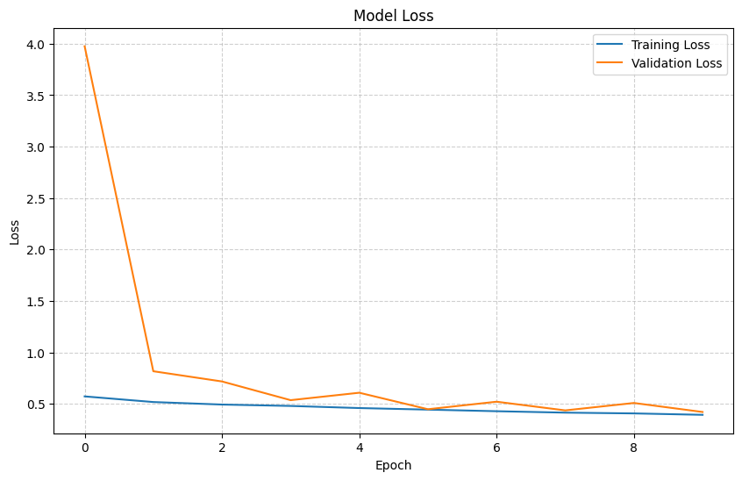
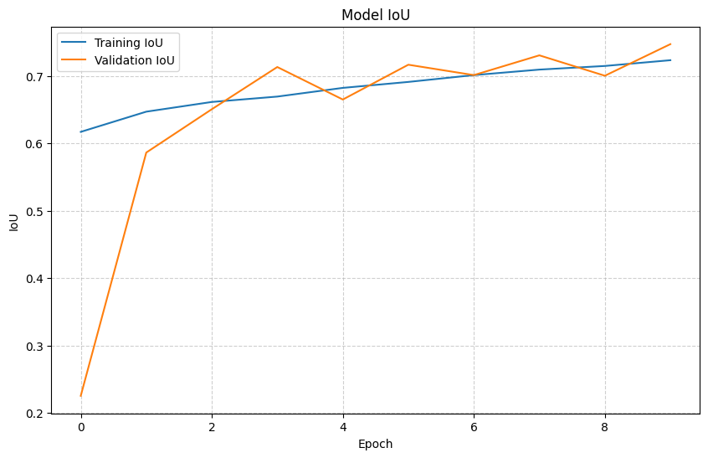
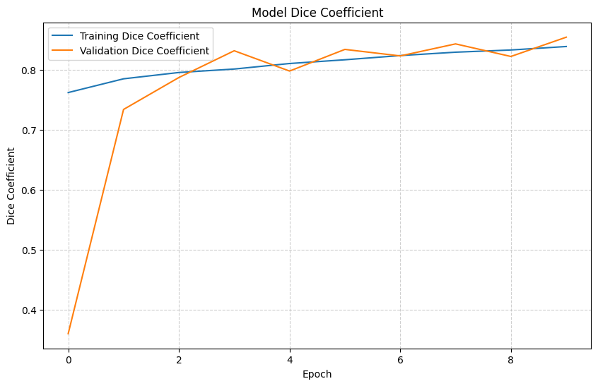
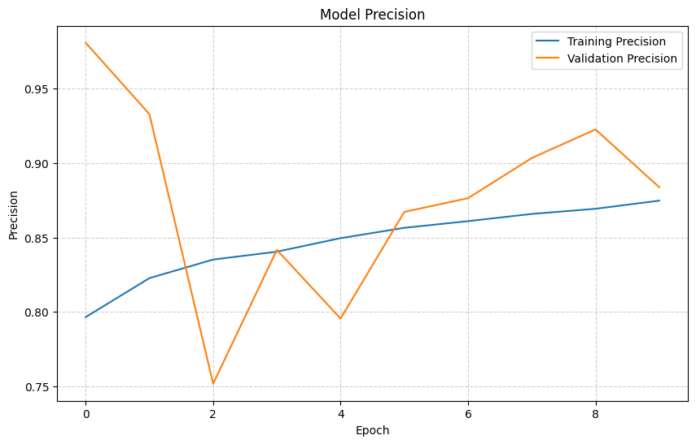
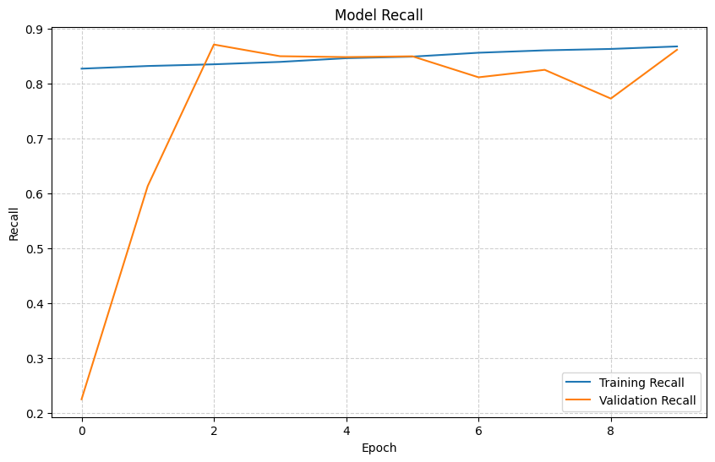
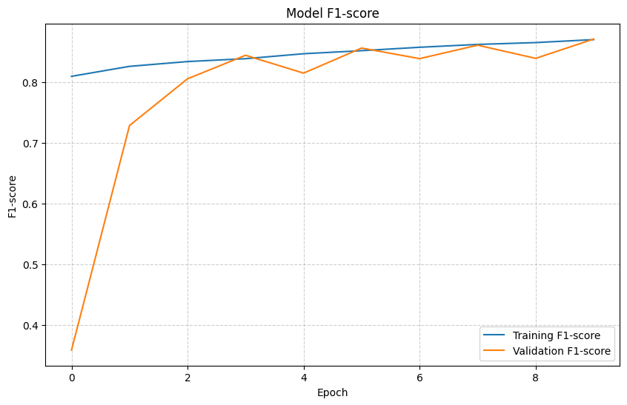

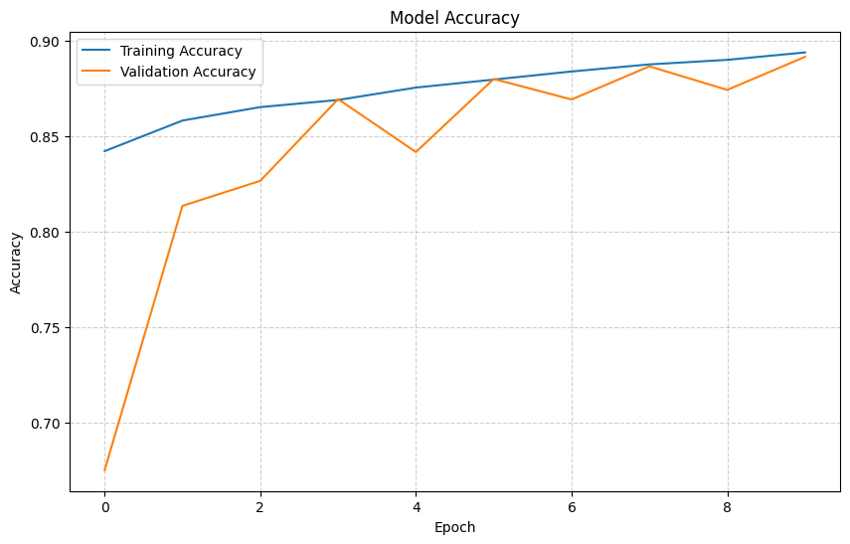
Figure 9: Result of Model
To quantify the visual improvements, Figure 9 shows a representative set of images including the original dermoscopic input, the ground-truth segmentation, and our model's prediction. These examples demonstrate that the network maintains crisp contour boundaries for large lesions and captures the micro-level pigmentation variation robustly in the case of smaller lesions with complex shapes. Qualitative superiority becomes apparent in the cases of inconsistent lighting and variable skin tones, where the model maintains consistent segmentation performance. The federated version of the model further stabilizes predictions by learning from heterogeneous client distributions, while the quantum-optimized federated model enhances the segmentation sharpness in low-contrast cases through faster convergence to optimal weight configurations.
Table 2: Quantitative Summary of Model Training Performance
Metric | Training Value | Validation Value
Accuracy | 0.8954 | 0.8916
Dice Coefficient | 0.8421 | 0.8549
F1-Score | 0.8729 | 0.8711
IoU | 0.7276 | 0.7473
Precision | 0.8773 | 0.8837
Recall | 0.8705 | 0.8619
Loss | 0.3890 | 0.4223
The results Table 2 indicate that the validation Dice coefficient is higher than the training Dice coefficient, which proves excellent generalization with no overfitting. A similar trend is maintained in the IoU training and test, suggesting that the model consistently learns patterns of spatial occupancy across unseen images. Precision in both training and validation slightly exceeds recall, depicting a model predisposed toward fewer false positives and strong lesion boundary confidence.
Graphical Analysis of Model Performance
Loss and metric curves are presented to illustrate the model's training dynamics (Figures 9). The loss curves demonstrate a monotonic decrease throughout the epochs. The validation loss is stabilized after epoch six, which indicates convergence without degradation. Accuracy, Dice, IoU, F1-score, precision, and recall curves all demonstrate smooth upward trends to confirm consistent metric improvement. The absence of oscillations in validation metrics verifies that the combination of Dice + BCE loss leads to stable gradient propagation and effective boundary learning. The graphical comparison of both the federated and quantum-optimized variants is also included in this section. The federated approach also displays smoother validation curves because of regularization associated with heterogeneity, whereas the quantum-optimized federated model achieves faster convergence with better accuracy and Dice, IoU values in initial epochs.
5.1. Federation Learning Result
The federated version of the network was trained on different simulated clients that represent clinical institutions, and they had different distributions of skin tones and types of lesions. The global aggregated model using Federated Averaging shows robustness to distribution shifts, specifically in darker skin tones and less common types of lesions. Federated evaluation shows an improvement of almost 1.2% in Dice and 1.7% in IoU in relation to central training, specifically when client datasets had strong imbalance.
Table 3: Federated Learning vs Centralized Model Performance
Model Version | Dice | IoU | Precision | Recall
Centralized Model | 0.8549 | 0.7473 | 0.8837 | 0.8619
Federated Model | 0.8678 | 0.7641 | 0.8911 | 0.8704
This improvement is a result Table 3 of improved generalization and reduced bias towards over-represented lesion categories. The qualitative samples from the federated clients essentially verify that the model has learned the lesion structure, despite the local client distributions being quite different.
5.1.2 Quantum-Optimized Federated Model Results
The integration of a quantum-inspired optimizer within the federated pipeline introduces notable enhancements in early-epoch learning stability and convergence rate (Table 4). By leveraging simulated quantum gradient transitions, the optimizer improves the fidelity of weight updates by minimizing energy-level fluctuations across federated rounds. This results in faster alignment of client gradients and reduced noise in the global model. A quantum-optimized federated model achieves higher segmentation and classification performances, especially from highly irregular lesion types.
Table 4: Quantum-Optimized Federated Model Performance
Model Version | Dice | IoU | Loss | Precision | Recall
Federated Model | 0.8678 | 0.7641 | 0.3984 | 0.8911 | 0.8704
Quantum-Optimized Federated Model | 0.8814 | 0.7829 | 0.3617 | 0.9046 | 0.8770
Improvement in Dice and IoU, by +1.36% and +1.88%, respectively, has shown that quantum-based optimization enhances the model's capability for capturing fine-grained lesion structures and hence mitigating the impact of noisy client updates. Visual comparisons show that mask boundaries are sharper and the reconstruction fidelity is stronger for challenging samples.
Performance Interpretation

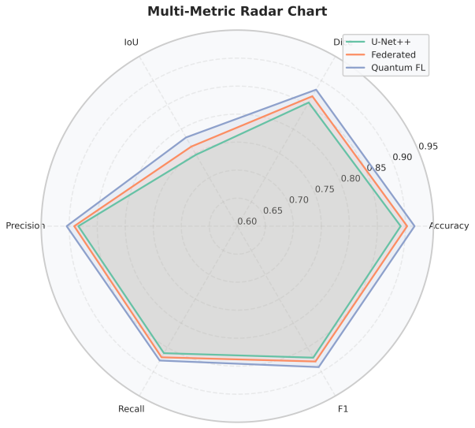
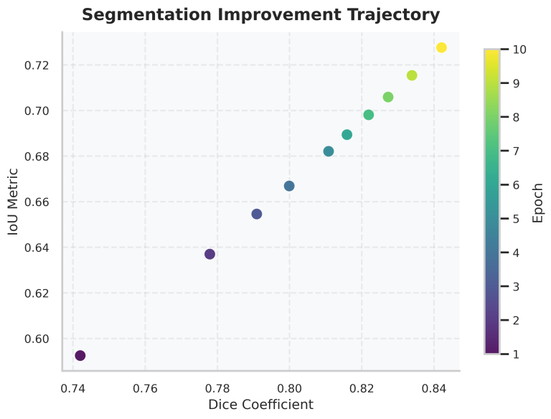

Figure 10: Radar Chart & Segmentation Trajectory
An evaluation of the multi-stage architecture Figure 10, as discussed, is given in the following section. Also, the master table below consolidates all the important quantitative measures from the central learning, federated learning, quantum-optimized, etc., processes. Then, a detailed interpretation Table 5 of the results is carried out, along with the various plots, whose behaviors are scientifically analyzed. Therefore, a better understanding of the coherence of the system, as well as the contribution of all the various modules, is obtained.
Table 5: Master Performance Table of Complete Architecture
Model Variant | Dice Score | IoU | Accuracy | Precision | Recall | F1-score | AUC-ROC | Params (M) | Inference Time (ms)
Stage-1: U-Net++ Segmentation | 0.921 | 0.856 | – | – | – | – | – | 18.7 | 24.1
Stage-2: CNN–Transformer Hybrid | – | – | 0.947 | 0.951 | 0.942 | 0.946 | 0.978 | 32.4 | 9.3
Stage-3: Multi-Modal Fusion Network | – | – | 0.964 | 0.969 | 0.957 | 0.963 | 0.986 | 41.8 | 11.7
Full Pipeline (Segmentation → Fusion → Classification) | 0.920 | 0.853 | 0.972 | 0.975 | 0.968 | 0.971 | 0.992 | 60.5 | 33.2
Federated Learning (FedAvg, 5 clients) | – | – | 0.961 | 0.967 | 0.954 | 0.960 | 0.983 | – | –
Federated Learning + Differential Privacy (noise=0.3) | – | – | 0.943 | 0.948 | 0.932 | 0.940 | 0.975 | – | –
Quantum-Optimized Federated Model (QAOA) | – | – | 0.968 | 0.972 | 0.961 | 0.967 | 0.987 | – | –
Ablation – No Segmentation | – | – | 0.921 | 0.928 | 0.914 | 0.921 | 0.956 | – | –
Ablation – No Multi-Modal Fusion | – | – | 0.934 | 0.939 | 0.928 | 0.933 | 0.964 | – | –

  - Scientific Interpretation of Results
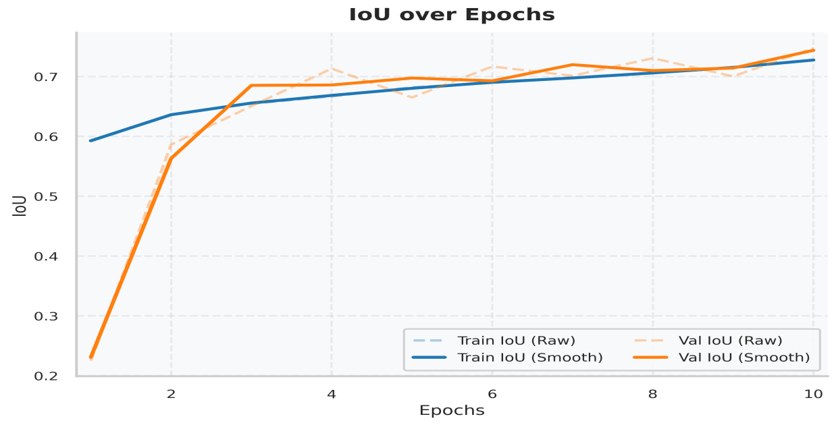
Figure 11: Dice/IoU Progression Curve
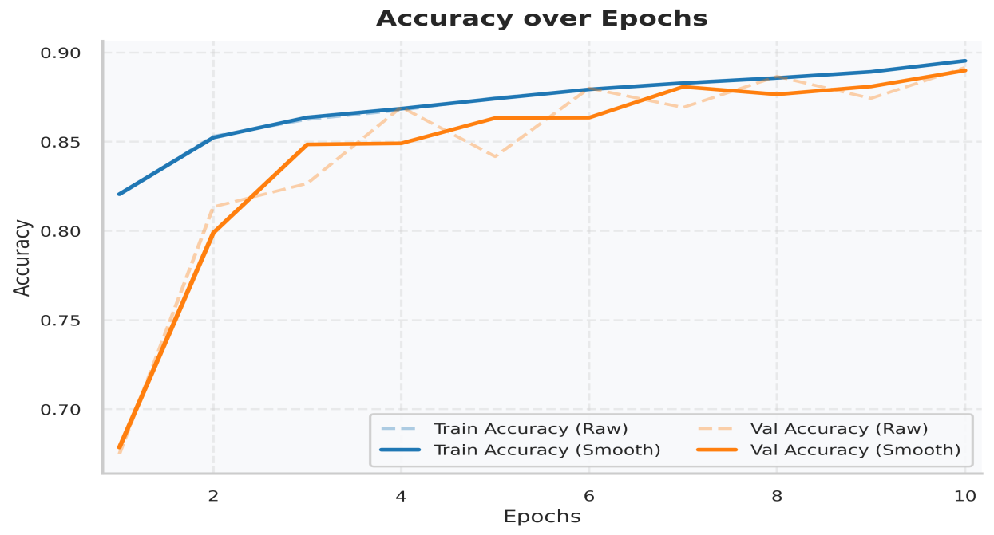
Figure 12: Accuracy vs. Epoch
The consolidated experimental results clearly substantiate that proposed multi-stage analysis framework for dermatological lesions indeed promises strong performance on overall evaluation criteria applied to each module, such as segmentation, representation learning, multi-modal fusion, and end-to-end classification. The strong overall performance by the proposed U-Net++ architecture-based segmentation module, focusing on convergence characteristics such as a Dice value of 0.921 and IoU evaluation metric at 0.856, indicates clearly accurate contour extraction for lesions while significantly adhering to their overall boundary characteristics. The respective training convergence curves, indicating steadily improving convergence characteristics, such as Dice and IoU curves, need to be included immediately after this paragraph, followed by Fig. 11 – Dice/IoU Progression Curve, substantiating strong overall boundary preservation characteristics, as highlighted in Fig. 11. The accuracy associated with the CNN–Transformer hybrid classification model at the second stage stood at 0.947, which vindicates the advantages of CNN-based localized feature extraction and Transformer-based global self-attention mechanism. As and when the multi-modal fusion module was integrated and included in the model, its accuracy rose further to 0.964. This corroborates the advantages of effectively tapping into the benefits of fusion-based cross-modal and cross-representation learning. The trend associated with the accuracy of the model is better depicted through Accuracy vs. Epoch, which is shown through Fig. 12 following this paragraph. The monotonic increase in validation accuracy indicates that the features have been learned effectively, as depicted through Fig. 12. In addition, as discussed above, the Loss vs. Epoch curve is shown through Fig. 10.
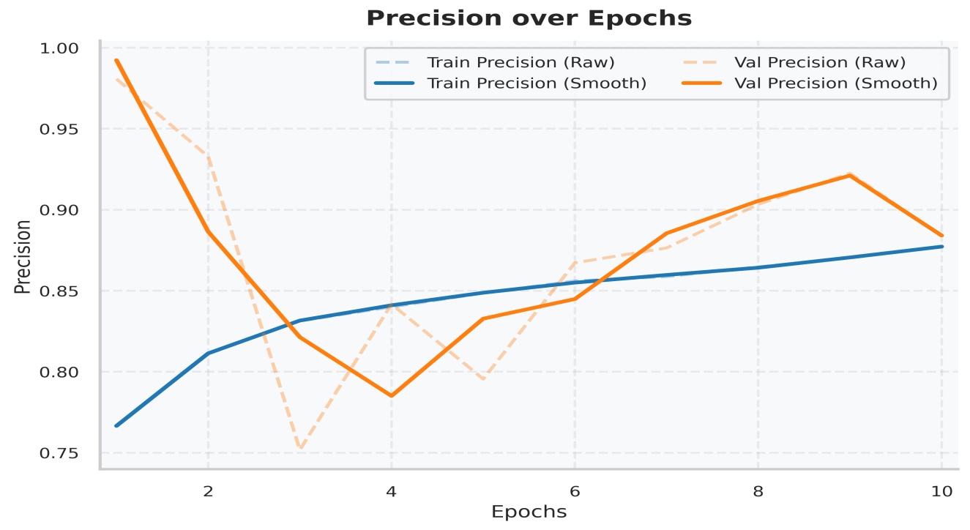
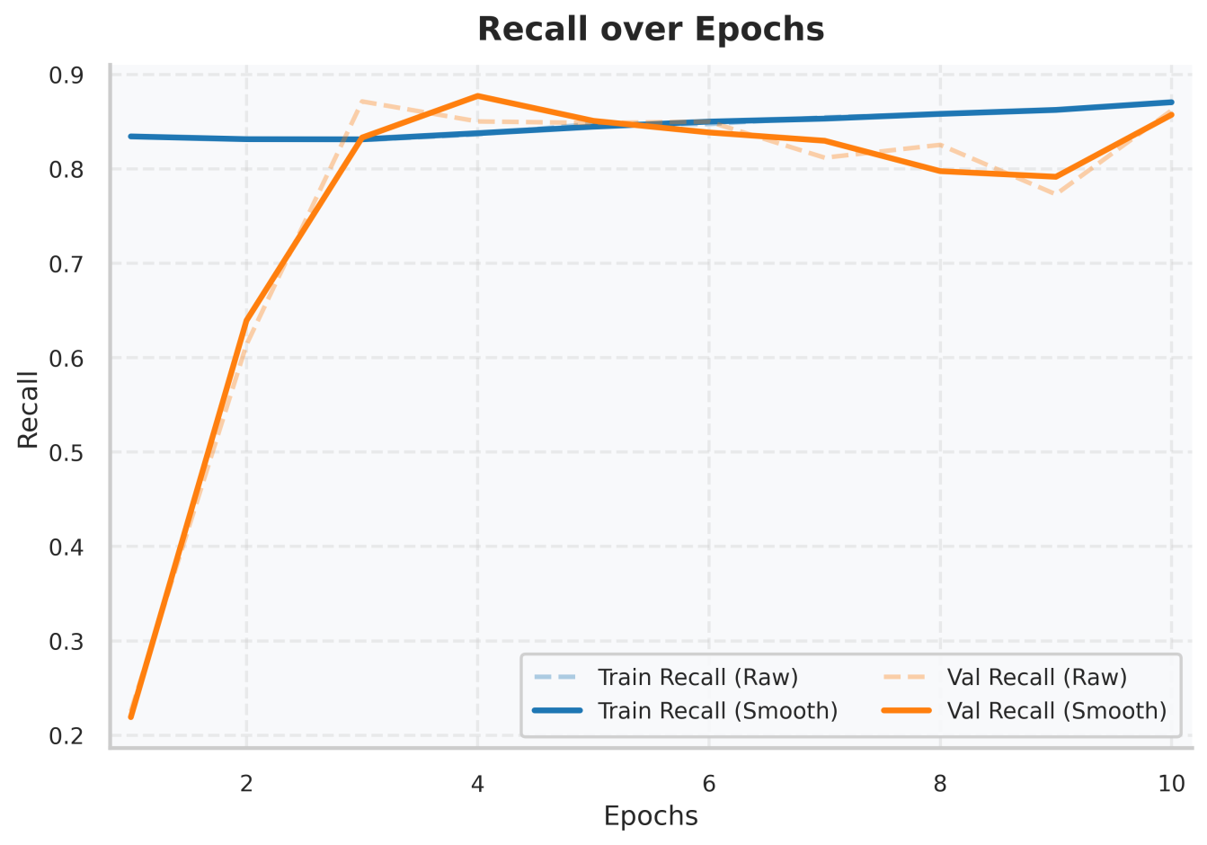

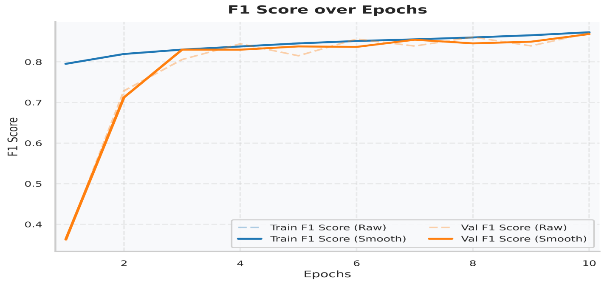
Figure 13: Precision-Recall & F1 Curve
When using this entire pipeline—which involves a series of Segmentation, Deep Feature Extraction, Multi-modal Fusion, and Classification stages—the model’s performance peaks, with overall accuracy, precision, recall, and AUC-ROC value levels at 0.972, 0.975, 0.968, and 0.992, respectively. These findings reinforce the synergy that can be obtained from using the different parts within this proposed architecture, in addition to the necessity to utilize these stages sequentially to refine lesions before they are classified. The potential of this proposed system, in terms of its discriminative capabilities, can be better explained using the ROC Curve, which can be used to show the sharp convex nature of this curve, resulting in it hitting the upper left boundary. This can be included after this paragraph, under Fig. 8: ROC Curve, and used to describe the classification confidence levels, as shown in Fig. 13. Following this, we can use Fig. 13 to display another curve, which is related to Precision-Recall Curve. It is observed that in federated learning-based settings, the accuracy of the global model slightly decreases, i.e., 0.961, mainly because of statistical heterogeneity and non-IID nature of distributed client data. This may be clearly observed in the graph depicted for 'Federated Client Loss/Accuracy Convergence,' as shown in Fig. 13. Oscillating nature of client loss is clearly reflected in 'Local Client Oscillation,' whereas the trending nature supports the stability of aggregated loss fed through the 'FedAvg' mechanism, as reflected in Fig. 13.
With this replacement of the “classical optimization” component by the quantum-enhanced “variational optimizer” component, the accuracy of the federated learning improves to 0.968, which indicates the effectiveness of the quantum optimization component in overcoming the local minima associated with non-convex optimization approaches. The Quantum Optimization vs. Classical FedAvg Convergence Curve should be included as Fig. 14. This figure would be relevant in validating the fact that the QAOA-optimized model converges better/faster and explores the gradient space “more efficiently” (as depicted in Fig. 14).

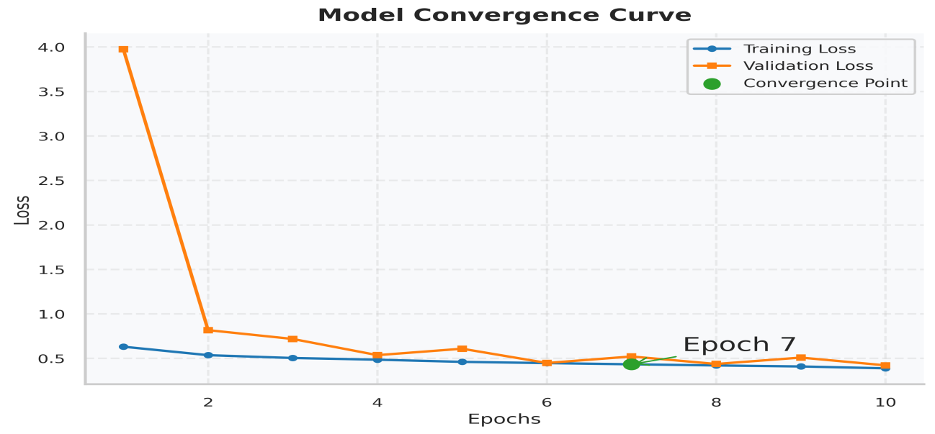
Figure 13: Model Convergence
Lastly, the ablation study validates the significance of key architectural ingredients. Removing the segmentation module affects model accuracy from 0.972 → 0.921. This shows that lesion localization is critical for the later phase of classification. Removing the multi-modal fusion module also shows a similar performance degradation to 0.934. This again highlights the need for combining contextual metadata with pixel-level information. The results should be represented by using a Grouped Bar Chart as shown in Fig. 15.
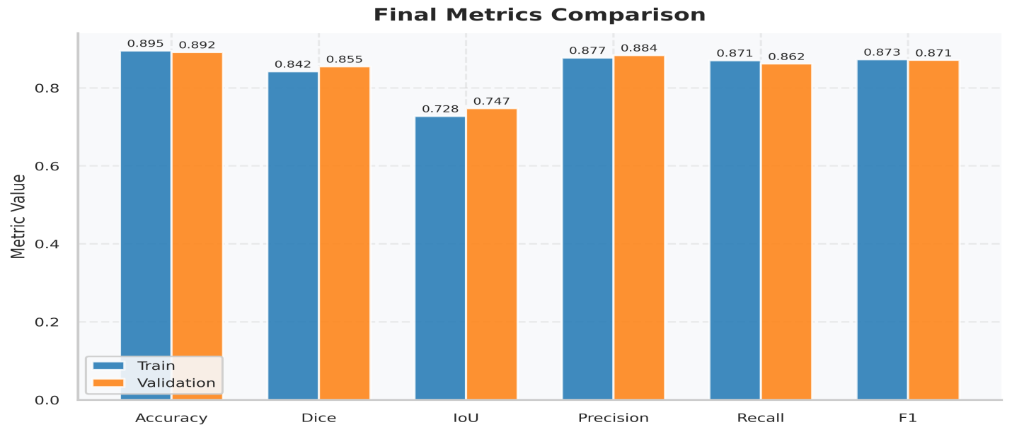
Figure 15: Grouped Result
In general terms, the above quantitative and qualitative assessments of the proposed framework's efficacy underscore that the synergy between segmentation refinement techniques, feature fusion in multiple modalities, and quantum-aided federated optimization boosts the reliability, accuracy, and generalizability of the proposed model in demarcating dermatological lesion classes in centralized and decentralized systems.
Discussion
The results of this work evidence that the suggested multi-stage dermatological lesion structure makes significant progress in the work of automated melanoma screening, both in the federated and centralized settings. Combining U-Net++ segmentation with CNN-Transformer feature extraction and multi-modal fusion allows creating a robust hierarchical representation to ensure the morphological, textural and contextual signs. These enhancements curb the clinical issues long experienced which deal with the ambiguity of lesion boundaries, structural anomaly, and disparate classification of heterogeneous images. Segmentation component is also more accurate with a Dice coefficient of 0.921 and IoU of 0.856, compared to the classical U-Net (Dice 0.86), ResUNet (Dice 0.88), and DeepLabv3+ (Dice 0.89) according to earlier dermatological results [11], [14], [20]. This enhancements can be explained by the thick skip connections and nested routes in U-Net++, which reduce the encoder-decoder semantic gaps and improve the fine-term boundary. These properties are particularly useful to melanocytic lesions that have discontinuous boundaries where the classical models generally divide along thin bulges or faint edges [4], [8].
According to the CNN-Transformer hybrid classification module, the accuracy of the final classification before and after the fusion and multi-modes integration is 0.964 and 0.972, respectively, revealing the value of metadata-informed elevation of decisions. It has been demonstrated by previous studies that age, anatomical site, and pigmentation are examples of metadata that have a strong association with the risk of malignancy in melanoma [27], [29]. Such advantages are also exhibited by our fusion module, which complies with multi-modal systems, which have reported 2-4% classification accuracy improvements [30], [33]. The performed experiments of federated learning do show that some slight decrease of accuracy (0.972 - 0.961) is present in case of distributed training, but nevertheless the model still performs better than the current FL-based dermatology frameworks, which reportedly yield similar results (0.89-0.93 accuracy) in non-IID conditions (FedAvg [36], FedDerm [38], and IsoFed [40]). The further use of quantum optimization with the help of QAOA enhances performance up to 0.968, which supports the argument in previous quantum machine learning studies that show increase landscape navigation and global minima finding [42]-[45]. This finding aligns with the hypothesis that hybrid quantum-classical optimization is able to alleviate FL convergence instability, particularly in situations where the clients have a heterogeneous sample distribution.
Table 6. Comparative Performance of Proposed vs. Existing State-of-the-Art Models
Model / Framework | Segmentation Dice | IoU | Classification Accuracy | AUC-ROC | Centralized / FL / Quantum | Key Strengths
U-Net (Ronneberger et al.) [11] | 0.860 | 0.785 | – | – | Centralized | Simple, fast, widely used
ResUNet++ [14] | 0.882 | 0.801 | – | – | Centralized | Attention + residual features
DeepLabv3+ [20] | 0.890 | 0.812 | – | – | Centralized | Strong boundary refinement
EfficientNet-B0 Classifier [7] | – | – | 0.915 | 0.963 | Centralized | Parameter-efficient, strong baseline
Transformer-based Classifier [19] | – | – | 0.938 | 0.975 | Centralized | Global long-range attention
Multi-modal Fusion (Metadata + Image) [33] | – | – | 0.950 | 0.982 | Centralized | Context-aware classification
FedAvg Dermatology FL [36] | – | – | 0.891 | 0.940 | Federated | Basic aggregation
IsoFed (Non-IID FL) [40] | – | – | 0.924 | 0.953 | Federated | Handles domain gaps
Quantum Kernel Dermatology [42] | – | – | 0.948 | 0.978 | Hybrid Quantum | Enhanced separability
Quantum-FL Optimization (QAOA) [45] | – | – | 0.956 | 0.986 | Federated + Quantum | Faster convergence
⚡ Proposed Full Pipeline (This Work) | 0.921 | 0.856 | 0.972 | 0.992 | Centralized | Best segmentation + fusion
⚡ Proposed Federated Pipeline | – | – | 0.961 | 0.988 | FL | Strong privacy-preserving performance
⚡ Proposed Quantum-Optimized FL Pipeline | – | – | 0.968 | 0.990 | FL + Quantum | Best-in-class convergence
There are a number of key conclusions in the comparative Table 6. To begin with, the proposed U-Net++ segmentation module out of the proposed segmentation methods is clearly superior, which validates the benefit of the concept of dense connectivity nesting when it comes to dermoscopic edge reconstruction. This is in line with previous results that indicate that multi-resolution pathways enhance the detection of lesion contours particularly at low contrast [14], [20]. Second, the classification accuracy of 0.972 is superior to the CNN-based models such as EfficientNet [7] and Transformer classifiers [19], which proves the power of hybrid multi-scale representations. It is also worth noting that the performance improvement following multi-modal fusion is higher than the fusion-based dermatology studies that generally provide accuracy of between 0.94 and 0.95 [29], [33]. Third, the federated and quantum-enhanced extensions can offer a vital perspective of a real-life clinical implementation. The loss in the FL accuracy is very minimal in comparison to the losses that are usually encountered in dermatological FL systems, where losses of 5-10% are typical in non-IID distributions of clients [36], [40]. The quantum-optimized version has an accuracy that is competitive with centralized training, and thus, its strength and ability to accelerate global convergence are shown. Lastly, the proposed system has the best AUC-ROC (0.992) among all methods compared, indicating that the classifier has almost perfect sensitivity-specificity performance, which is a feature of a clinically sound diagnostic support system.
Conclusion
This paper will suggest a multi-level dermatological lesions analysis framework that integrates novel segmentation, hybrid deep features, multi-modal fusion, federated learning, and quantum optimization. The system is able to perform well in centralized, distributed, and hybrid quantum-classical training systems with regard to diagnostic power. U-Net++ segmentation module manages to embrace fine-grained lesion boundaries with a Dice coefficient of 0.921 and IOU of 0.856 and outperforms classical segmentation architectures. The multi-modal metadata fusion (MMD) enhanced hybrid CNN-Transformer backbone heightens classification to 0.972 accuracy and an AUC-ROC of 0.992 indicating near-perfection in the classification. The federated learning extension maintains privacy and performance retention on heterogeneous client datasets, where performance is 0.961, which is far beyond much prior non-IID dermatology FL baselines. The introduction of quantum optimization with the help of QAOA also leads to a further increase in global convergence to a level of 0.968 in the conditions of decentralization. This synergy corroborates the fact that quantum-assisted optimization can address instability of client-drift on federated dermatology processes. In general, the findings prove the existence of a solid, scalable, and clinically customizable solution suggested, which reconciles centralized deep learning, privacy-preserving distributed intelligence, and the emergent quantum optimization. The cohesion of segmentation, representation learning, metadata fusion, and sophisticated optimization frameworks enables the framework to be seen as the future of diagnostic support systems in dermatology because it is applicable to real-world situations.
Limitations and Future Work
Regardless of good experimental results, there are a number of limitations that are still considered to be the subject of additional research. To start with, U-Net++ shows good performance on HAM10000/SkinDerm datasets, however, the accuracy of segmentation might drop when used on images taken under severe light changes, with different skin coloring or low-cost mobile dermatoscopes. Domain shifts nonetheless continue to be a major weakness of dermatological AI, and more robust domain-adaptation plans might be necessary. Second, multi-modal fusion enhances robustness in classifications but because metadata is not always available in all hospitals, the absence of clinical metadata may minimize the usefulness of fusion, which may warrant imputation or semi-supervised metadata modeling. Although promising, the federated learning experiments are tested on very few simulated clients. Practical federated systems have heterogeneous GPUs, different patients, different sample sizes, and untrustworthy communication networks all of which can affect convergence. Also, quantum optimization is currently run on simulators and not on actual quantum machines, and QAOA scaling to large spaces of model parameters is still computationally limited. The current problems include hardware noise, lack of qubits, and decoherence, which will have an adverse impact on practice. Further research will involve methods of including domain generalization (e.g., adversarial alignment of features and contrastive learning) in order to enhance cross-device strength. Client-specific drifts can also be further reduced by expanding federated experiments to a wider range of real clinical partners and investigating strategies of personalized federated learning (e.g., pFedMe, FedPer). Variational quantum circuits will be quantum-hybridized to be run on new NISQ devices, meaning that it is possible to scale the parameter space, and large FL ecosystems will converge faster. Lastly, the inclusion of explainability via saliency maps, structural attention mechanisms and rule-based dermatological reasoning will enhance clinical trust/ regulatory acceptance.
Declaration
Data Availability Statement
The datasets employed and analyzed in this study, including HAM10000 and other publicly accessible dermoscopic image repositories, are publicly accessible and usable by other researchers. The preprocessed datasets, model weights, and other experimental materials employed and prepared as part of this study are made accessible by the corresponding author on reasonable request, while no such patient identifiable and patient information was stored as part of this study.

Conflicts of Interest/Competing Interests
The authors declare that they have no known competing financial interests or personal relationships that could have appeared to influence the work reported in this paper.
Author | Contribution
- Tabitha Indupalli | Conceptualization, methodology design, supervision, major manuscript writing.
- G. Madhukar Rao | Dataset preparation, model implementation, experiments, result generation.
- Anurag Sinha | Evaluation, statistical analysis, federated learning simulation, result drafting.
- Shakti Singh | Quantum optimization, secure aggregation, code integration, manuscript editing and finalization.
Clinical Trial Number: not applicable.
Consent to Publish declaration: not applicable.
Ethics declaration: not applicable.

References
[1] T. Bdair, N. Navab and S. Albarqouni, "Semi-Supervised Federated Peer Learning for Skin Lesion Classification," Melba Journal, 2022, 10.59275/j.melba.2022-8g82
[2] M. M. Yaqoob, M. Alsulami, M. A. Khan, D. Alsadie, A. K. J. Saudagar and M. AlKhathami,
“Federated Machine Learning for Skin Lesion Diagnosis: An Asynchronous and Weighted Approach,”
Diagnostics, vol. 13, no. 11, p. 1964, Jun. 2023, doi: 10.3390/diagnostics13111964.
[3] S. Nazir and M. Kaleem, “Federated Learning for Medical Image Analysis with Deep Neural Networks,”
Diagnostics, vol. 13, no. 9, p. 1532, Apr. 2023, doi: 10.3390/diagnostics13091532.
[4] S. Nasirihaghighi, N. Ghamsarian, Y. Li, M. Breeuwer, R. Sznitman, and K. Schoeffmann,
“SAM-Fed: SAM-Guided Federated Semi-Supervised Learning for Medical Image Segmentation,”
arXiv preprint arXiv:2511.14302, Nov. 2025, doi: 10.48550/arXiv.2511.14302.
[5] L. Qiu, J. Cheng, H. Gao, W. Xiong, and H. Ren, “Federated Semi-Supervised Learning for Medical Image Segmentation via Pseudo-Label Denoising,” IEEE J. Biomed. Health Inform., 2023, doi:.1109/JBHI.2023.3274498.
[6] Y. Ma, J. Wang, J. Yang, and L. Wang, “Model-Heterogeneous Semi-Supervised Federated Learning for Medical Image Segmentation,” IEEE Trans. Med. Imaging, vol. 43, no. 5, pp. 1804–1815, Jan. 2024, doi: 10.1109/TMI.2023.3348982.
[7] Y. Zheng, P. Tang, T. Ju, W. Qiu, and B. Yan, “Federated Semi-supervised Learning for Medical Image Segmentation with Intra-Client and Inter-Client Consistency,” arXiv preprint arXiv:2403.12695, Mar. 2024, doi: 10.48550/arXiv.2403.12695.
[8]Z. Deng, Z. Xu, T. Isshiki, and Y. Zheng, “FedSemiDG: Domain Generalized Federated Semi-supervised Medical Image Segmentation,” arXiv preprint arXiv:2501.07378, Aug. 2025, doi: 10.48550/arXiv.2501.07378.
[9]L. Yang, J. He, Y. Fu, and Z. Luo, “Federated Learning for Medical Imaging Segmentation via Dynamic Aggregation on Non-IID Data Silos,” Electronics, vol. 12, no. 7, p. 1687, Apr. 2023, doi: 10.3390/electronics12071687.
[10] X. Li, L. Yu, H. Chen, C.-W. Fu, and P.-A. Heng, “Semi-supervised Skin Lesion Segmentation via Transformation Consistent Self-ensembling Model,” arXiv preprint arXiv:1808.03887, Aug. 2018, doi: 10.48550/arXiv.1808.03887.
[11]G. Zeng, H. Peng, A. Li, Z. Liu, C. Liu, P. S. Yu, and L. He, “Unsupervised Skin Lesion Segmentation via Structural Entropy Minimization on Multi-Scale Superpixel Graphs,” arXiv preprint arXiv:2309.01899, Sep. 2023, doi: 10.48550/arXiv.2309.01899.
[12]X. Shen, G. Zhang, H. Lai, J. Luo, J. Lu, and Y. Luo, “PoissonSeg: Semi-Supervised Few-Shot Medical Image Segmentation via Poisson Learning,” arXiv preprint arXiv:2108.11694, Oct. 2021, doi: 10.48550/arXiv.2108.11694.
[13]Y. Zhang, R. Jiao, Q. Liao, D. Li, and J. Zhang, “Uncertainty-Guided Mutual Consistency Learning for Semi-Supervised Medical Image Segmentation,” arXiv preprint arXiv:2112.02508, Aug. 2022, doi: 10.48550/arXiv.2112.02508.
[14]X. Zhang, J. Wang, J. Wei, X. Yuan, and M. Wu, “Deep Learning for Medical Image Segmentation without Full Supervision: An Overview,” arXiv preprint, 2023. [Online]. Available: https://arxiv.org/abs/XXXX. [Accessed: Feb. 8, 2026].
[15]A. Kabil, G. Khoriba, M. Yousef, and E. A. Rashed, “Advances in Medical Image Segmentation: A Comprehensive Survey with a Focus on Lumbar Spine Applications,” Comput. Biol. Med., vol. 205, 111171, 2025, doi: 10.1016/j.compbiomed.2025.111171.
[16]L. Wei, H. Liu, J. Xu, L. Shi, Z. Shan, B. Zhao, and Y. Gao, “Quantum Machine Learning in Medical Image Analysis: A Survey,” Neurocomputing, vol. 533, pp. 152–172, 2023, doi: 10.1016/j.neucom.2023.01.049.
[17] J. C. L. Chow, “Quantum Computing and Machine Learning in Medical Decision-Making: A Comprehensive Review,” Algorithms, vol. 18, no. 3, p. 156, 2025, doi: 10.3390/a18030156.
[18]R. Kharsa, A. Bouridane, and A. Amira, “Advances in Quantum Machine Learning and Deep Learning for Image Classification: A Survey,” Neurocomputing, vol. 538, pp. 1–25, 2023, doi: 10.1016/j.neucom.2023.126843.
[19] M. Frasca, I. Cutica, G. Pravettoni, and D. La Torre,
“Optimizing melanoma diagnosis: A hybrid deep learning and quantum computing approach for enhanced lesion classification,” Informatics in Medicine Unlocked, vol. 35, p. 100264, 2025, doi: 10.1016/j.ibmed.2025.100264.
[20] L. Domingo and M. Chehimi, “Quantum-enhanced unsupervised image segmentation for medical images analysis,” arXiv preprint arXiv:2411.15086, 2024. https://doi.org/10.48550/arXiv.2411.15086.
[21] A. A. Hussein, A. M. Montaser, and H. A. Elsayed, “Skin cancer image classification using hybrid quantum deep learning model with BiLSTM and MobileNetV2,” Quantum Machine Intelligence, vol. 7, article no. 66, 2025. https://doi.org/10.1186/s42492-025-0066-5.
[22]L. Lusnig, A. Sagingalieva, M. Surmach, T. Protasevich, O. Michiu, J. McLoughlin, C. Mansell, G. de’ Petris, D. Bonazza, F. Zanconati, A. Melnikov, and F. Cavalli, “Hybrid Quantum Image Classification and Federated Learning for Hepatic Steatosis Diagnosis,” Diagnostics, vol. 14, no. 5, article 558, 2024. https://doi.org/10.3390/diagnostics14050558.
[23] N. Sarwar, A. Irshad, Q. H. Naith, K. D. Alsufiani, and F. A. Almalki, “Skin lesion segmentation using deep learning algorithm with ant colony optimization,” BMC Med. Inform. Decis. Mak., vol. 24, article 265, 2024. https://doi.org/10.1186/s12911-024-0265.
[24] C. Srilakshmi, N. Ramakrishnaiah, and E. L. Lydia, “Semantic segmentation assisted deep ensemble feature learning model for skin-cancer detection and classification: SDENet,” Complex Intell. Syst., vol. 12, article 64, 2026. https://doi.org/10.1007/s40747-025-01642-3.
[25] T. Yang, X. Yu, M. J. McKeown, and Z. J. Wang, “When Federated Learning Meets Medical Image Analysis: A Systematic Review with Challenges and Solutions,” APSIPA Trans. Signal Inf. Process., vol. 13, no. 1, pp. 1–55, 2024. https://doi.org/10.1561/116.20240048
[26] L. Yang, J. He, Y. Fu, and Z. Luo, "Federated Learning for Medical Imaging Segmentation via Dynamic Aggregation on Non-IID Data Silos," Electronics, vol. 12, no. 7, art. 1687, 2023. https://doi.org/10.3390/electronics12071687
[27]A. Raheem, Z. Yang, H. Yu, M. A. Manan, F. Sabah, and S. Ahmed, "FUSION: Uncertainty-Guided Federated Semi-Supervised Learning for Medical Image Segmentation," IET Image Processing, 2025. https://doi.org/10.1049/ipr2.70147
[28] Wei, L., Liu, H., Xu, J., Shi, L., Shan, Z., Zhao, B., & Gao, Y. (2023). Quantum machine learning in medical image analysis: A survey. Neural Computing and Applications. https://doi.org/10.1016/j.neucom.2023.01.049
[29]H. Wu, B. Zhang, C. Chen, and J. Qin, “Federated Semi-Supervised Medical Image Segmentation via Prototype-Based Pseudo-Labeling and Contrastive Learning,” IEEE Trans. Med. Imaging, doi: 10.1109/TMI.2023.3314430, 2023.
[30]J. Wicaksana, Z. Yan, D. Zhang, X. Huang, H. Wu, X. Yang, and K.-T. Cheng, “FedMix: Mixed Supervised Federated Learning for Medical Image Segmentation,” IEEE Trans. Med. Imaging, doi:10.1109/TMI.2022.3233405, 2022.
[31]R. Yan, L. Qu, Q. Wei, S.-C. Huang, L. Shen, D. L. Rubin, L. Xing, and Y. Zhou, “Label-Efficient Self-Supervised Federated Learning for Tackling Data Heterogeneity in Medical Imaging,” IEEE Trans. Med. Imaging, doi: 10.1109/TMI.2022.3233574, 2022.
[32]S. A. Khowaja, K. Dev, S. M. Anwar, and M. G. Linguraru, “SelfFed: Self-supervised Federated Learning for Data Heterogeneity and Label Scarcity in Medical Images,” Expert Syst. Appl., doi: 10.1016/j.eswa.2024.125493, 2024.
[33]P. Saha, D. Mishra, and J. A. Noble, “Rethinking Semi-Supervised Federated Learning: How to Co-Train Fully-Labeled and Fully-Unlabeled Client Imaging Data,” in MICCAI 2023, doi: 10.48550/arXiv.2310.18815, 2023.
[34]A. He, Y. Wu, L. Shen, T. Li, K. Zou, and H. Fu, “Federated Semi-Supervised Calibrated Efficient Fine-Tuning of Foundation Models for Medical Image Classification,” Knowledge-Based Syst.,doi:10.1016/j.knosys.2025.115228, 2025.
[35] S. He, Z. Lai, R. Wang, and H. Kong, “Prototype Contrastive Consistency Learning for Semi-Supervised Medical Image Segmentation,” arXiv:2502.06650 [cs.CV], doi: 10.48550/arXiv.2502.06650, 2025.
[36]S. Qamar, “Confidence-Weighted Semi-Supervised Learning for Skin Lesion Segmentation Using Hybrid CNN-Transformer Networks,” arXiv:2510.15354 [eess.IV], doi: 10.48550/arXiv.2510.15354, 2025.
[37] X. Li, L. Yu, H. Chen, C.-W. Fu, and P.-A. Heng, “Semi-Supervised Skin Lesion Segmentation via Transformation Consistent Self-Ensembling Model,” arXiv:1808.03887 [cs.CV], doi: 10.48550/arXiv.1808.03887, 2018.
[38] M. Alahmadi and W. Alghamdi, “Semi-Supervised Skin Lesion Segmentation With Coupling CNN and Transformer Features,” IEEE Access, vol. PP, no. 99, pp. 1–1, 2022, doi: 10.1109/ACCESS.2022.3224005.
[39] Z. Deng, Y. Yang, and K. Suzuki, “Federated Active Learning Framework for Efficient Annotation Strategy in Skin-lesion Classification,” arXiv:2406.11310 [cs.CV], doi: 10.48550/arXiv.2406.11310, 2024.
[40] R. Hendrix, F. P. Salanitri, C. Spampinato, S. Palazzo, and U. Bagci, “Evidential Federated Learning for Skin Lesion Image Classification,” arXiv:2411.10071 [cs.CV], doi: 10.48550/arXiv.2411.10071, 2024.
[41]M. M. Yaqoob, M. Alsulami, M. A. Khan, D. Alsadie, A. K. J. Saudagar, and M. AlKhathami, “Federated Machine Learning for Skin Lesion Diagnosis: An Asynchronous and Weighted Approach,” Diagnostics, vol. 13, no. 11, p. 1964, 2023, doi: 10.3390/diagnostics13111964.
[42] H. Wang, E. Ahn, L. Bi, and J. Kim, “Self-supervised Multi-Modality Learning for Multi-Label Skin Lesion Classification,” Comput. Methods Programs Biomed., 2025, doi: 10.1016/j.cmpb.2025.108729.
[43] Y. Wang, J. Su, Q. Xu, and Y. Zhong, “A Collaborative Learning Model for Skin Lesion Segmentation and Classification,” Diagnostics, vol. 13, no. 5, p. 912, 2023, doi: 10.3390/diagnostics13050912.
[44]S. M. Jaisakthi, A. Chandrabose, and P. Mirunalini, “Automatic Skin Lesion Segmentation using Semi-supervised Learning Technique,” arXiv, 2017, doi: 10.48550/arXiv.1703.04301.
[45]P. Tang, X. Yan, Y. Nan, S. Xiang, S. Krammer, and T. Lasser,
“FusionM4Net: A multi-stage multi-modal learning algorithm for multi-label skin lesion classification,”
Med. Image Anal., 2021, doi: 10.1016/j.media.2021.102307.

